Moderating a Collaborate Session

Recommended browser: Firefox for moderators, participants may use other browsers.

Getting to Know the Collaborate Window
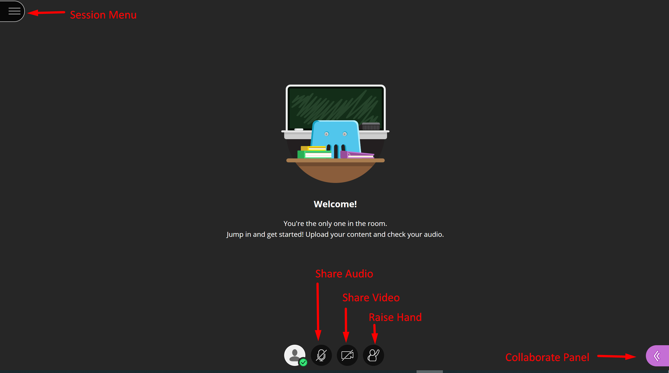
The tools that are available depend on the permissions set by the moderators.
Tool | Description
 | Open the Session Menu – moderator can start recording, attendees can get help, and leave the session.
 | Share Audio – toggles on/off
 | Share Video – toggles on/off
 | Raise Hand – allows attendees to ask the moderator a question using audio to prevent talking over one another if audio is enabled.
 | Open the Collaborate Panel – access chat, view attendees, share screen, adjust session settings.

When you enter a session, you will need to Share Audio and open the Collaborate Panel.
Session Menu  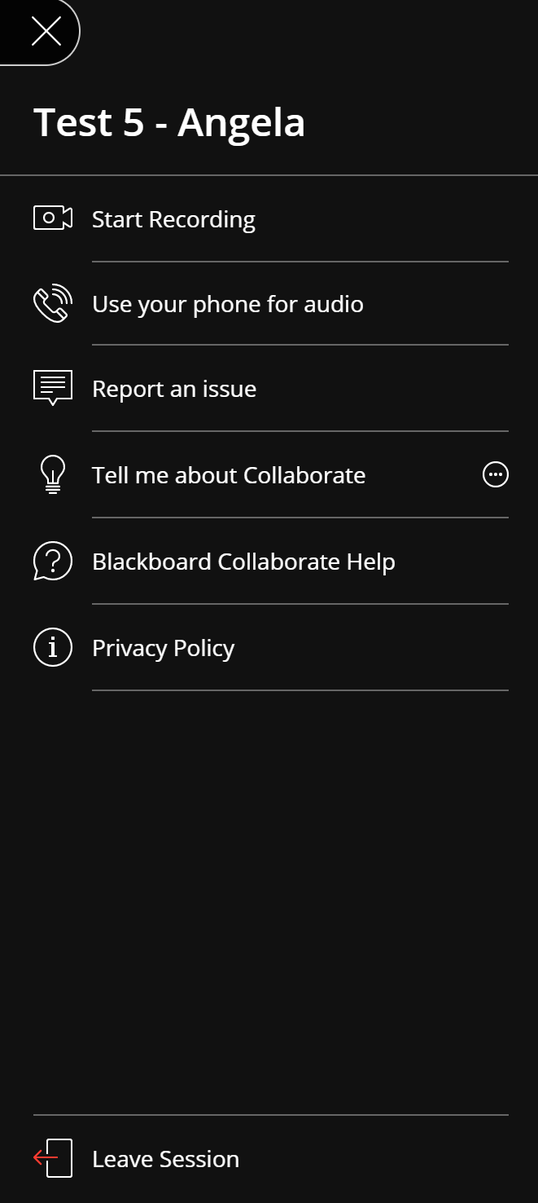 | Collaborate Panel  