Moodle Assignments

Important Assignment Settings
There are several important settings to be aware of when submitting assignments in Moodle.
These include:
- File Submission versus Online Text
- Due Dates and Cutoff Dates
- Draft versus Submission

File Submission vs. Online Text
There are two types of assignments in Moodle: File Submission and Online Text.
- File Submission assignments require you to attach a file and submit for grading. This might include essays, reports, spreadsheets, presentations, or any other file or document relevant to your course.
- Online Text assignments require you to type a response directly into a text box in Moodle.
Many assignments will include both file submission and online text, so be sure to read the instructions for your assignment carefully.

Due Dates vs. Cutoff Dates
The Due date is the date and time the assignment is due. Assignments submitted after this date may be counted late and points deducted from the overall grade. Late submissions will be marked in red text on the assignment grading page.
The Cutoff date is the date and time the assignment is closed for submissions. Instructors may deduct points for submissions through this date. You will no longer be allowed to submit the assignment beyond this date.

Draft vs. Submission
Depending on how your instructor has set up an assignment, when you submit text or a file to a Moodle assignment, the submission may be considered to be in Draft mode until the assignment reaches the due date. You may be able to remove, edit, and re-submit draft submissions until the due date when the files are submitted for grading by the assignment tool.
Once you have submitted an assignment, if you revisit the assignment page you will be able to follow the status of your assignment.
You will see the submission status (Submitted for Grading, or Draft (not submitted), the grading status, modification date, File submissions and Submission comments.
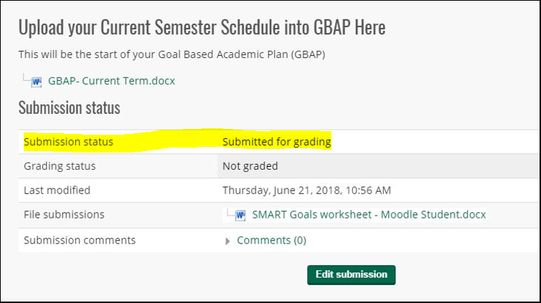
If the due date of the assignment has passed, the option to edit your submission will disappear.
You may have the option to modify your assignment if your instructor has allowed this option.
To modify your assignment, click on the Edit submission button, select the uploaded file, click delete, and then upload the correct version.
If you are ready to submit the final version of your assignment, click on Submit Assignment.

Submitting an Assignment
To access assignment instructions and upload a file for submission click the assignment name link (example highlighted below).

You will then see the assignment instructions, the current status of the assignment, and the Add submission button.
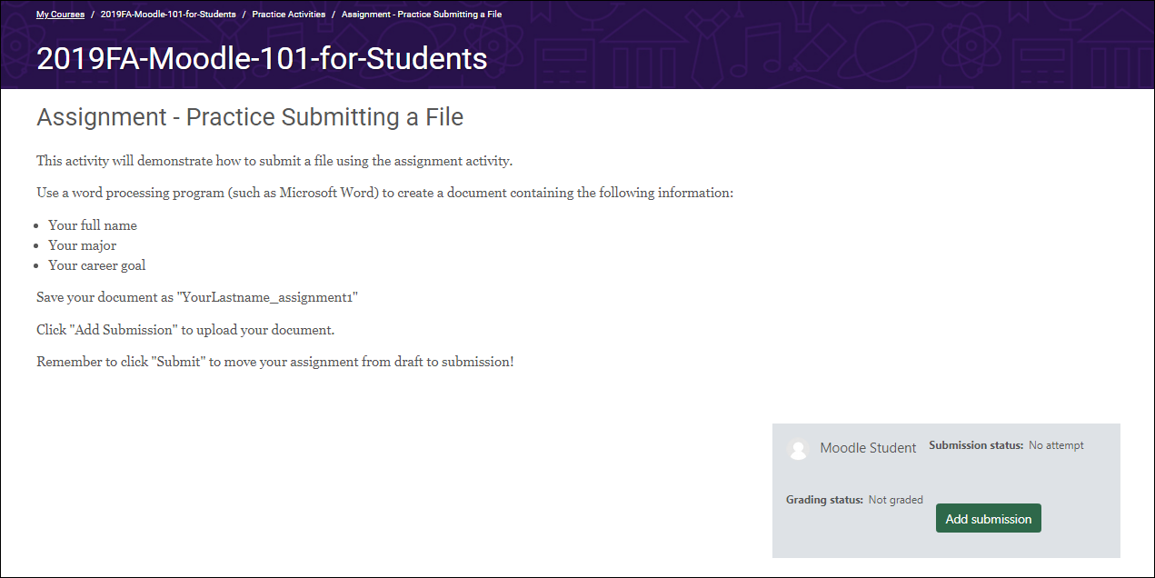

File Submission Assignments
A file submission assignment requires you to upload a file to Moodle.
1. Click the Add submission button.
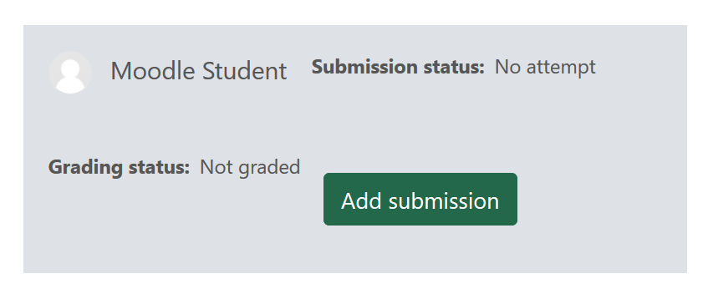
2. In the File Submissions box, you can either “drag or drop” a file from your computer into the box, or Click on the Add icon (outlined below) under File Submissions. If you use the drag and drop method, skip to Step 6.
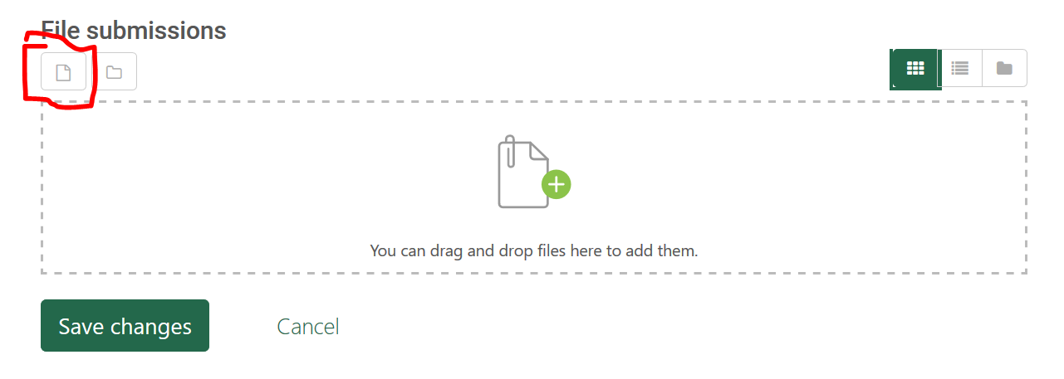
3. If you use the Add File method, click on Upload a file. Then click on Choose File.
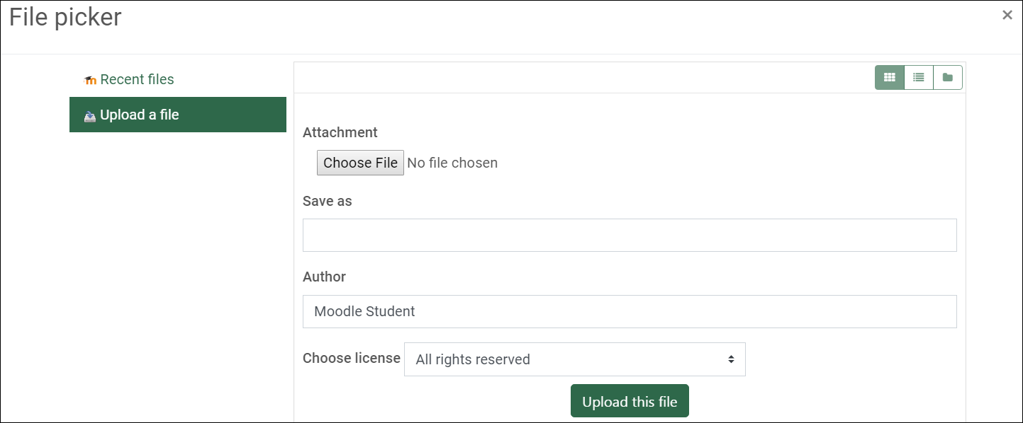
4. Locate and select the file you want to attach and click the Open button.
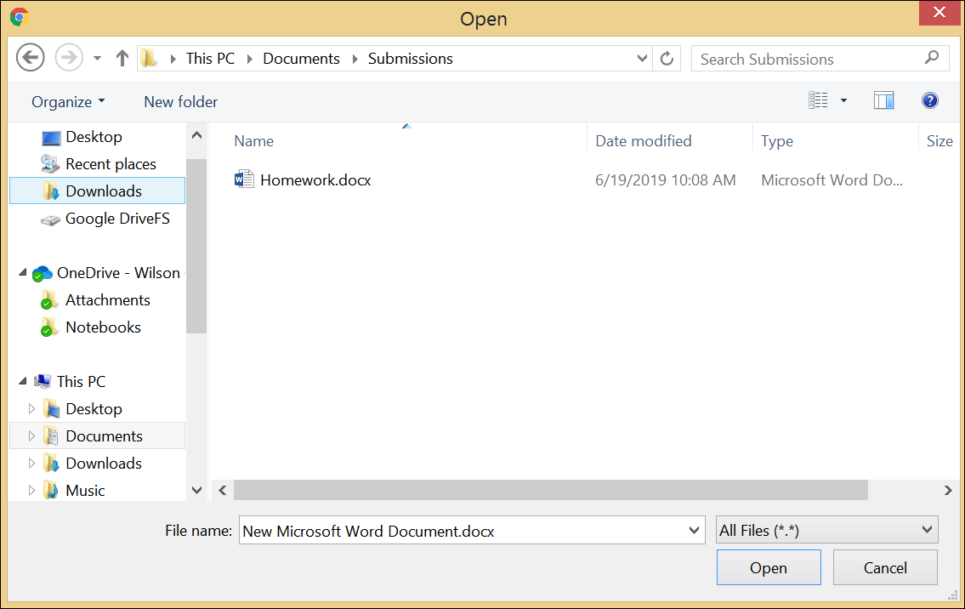

5. Verify that your file appears next to the Choose File button, and then click Upload this file.
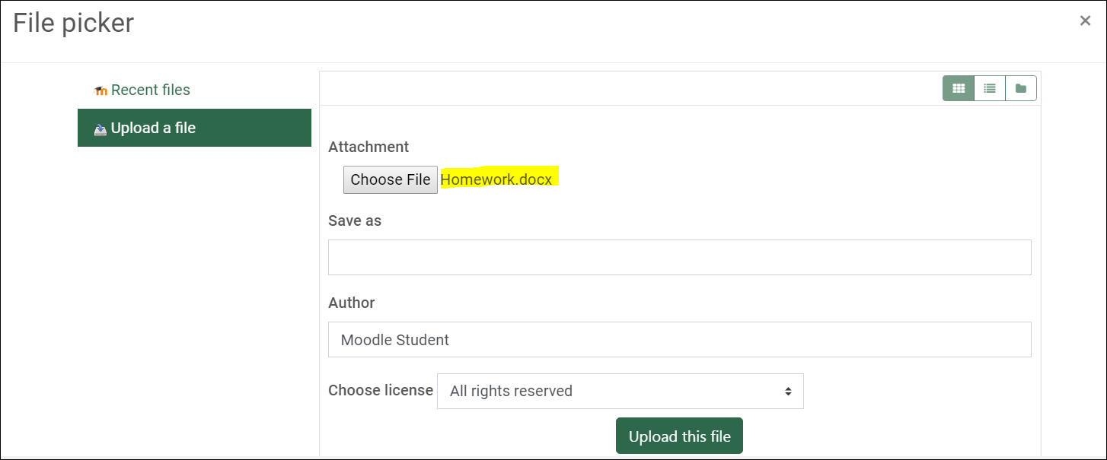
6. Next, verify that your file appears in the File submissions box (example file circled below) and then click Save changes.
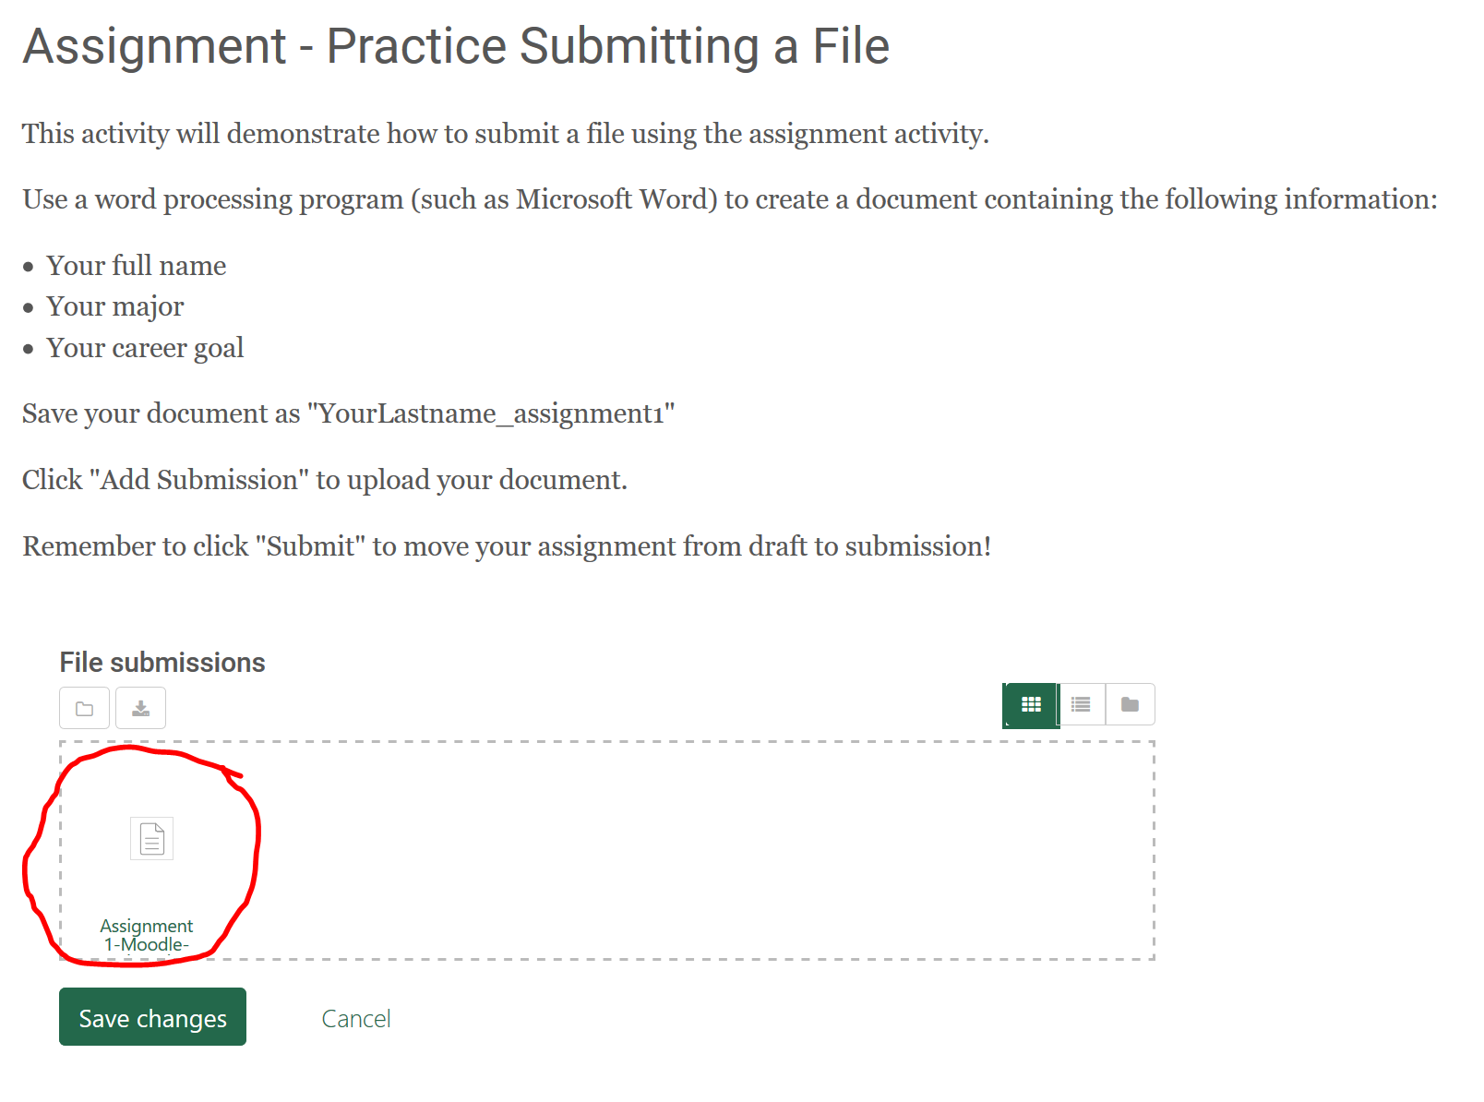

7. You will then be presented with a File Submission box that will show you that status of your submission and your uploaded file. If allowed, you can edit this submission up until the due date. Once you are satisfied with your submission, click Submit Assignment.
Note that your file is not officially submitted until you click on the Submit Assignment button or until the due date is reached.
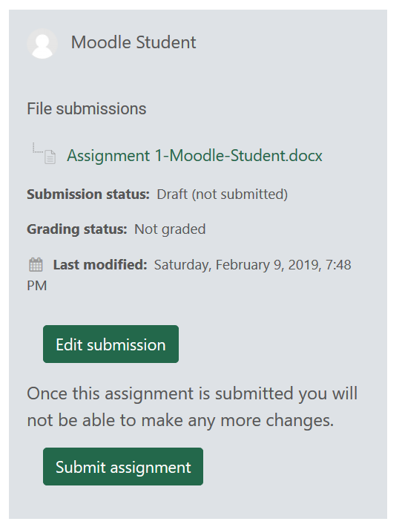

Online Text Assignments
How to access and submit an online text assignment:
1. Click on the assignment link.
2. Read the instructions provided by your instructor.
3. Click the Add submission button.
4. Type your response in the Online Text box and click Save Changes.
