Moodle Census Reporting Guidelines for NT, HY, and BL Courses

How to View Census Data from the IntelliBoard Instructor Dashboard
- This process works best using the Chrome browser.
- Must be done for each NT, HY, and BL course.
- These instructions are for reporting census data from the standard Enrollment Verification Quiz in Moodle.

Step 1: Login to Moodle

Step 2: Click the IntelliBoard Instructor Dashboard link.

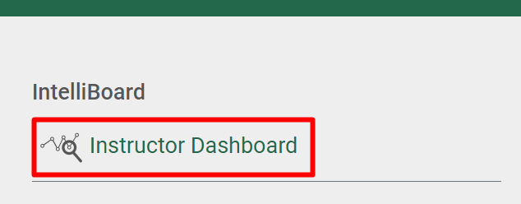

Step 3: Click Reports, Census Report.

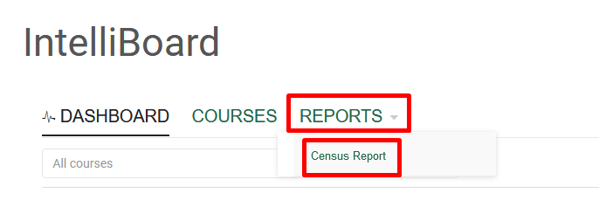

Step 4: Change the criteria as indicated below for each outlined box.

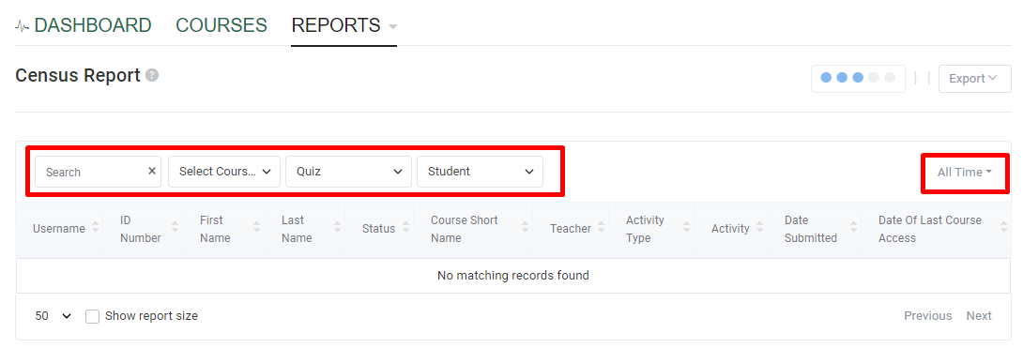

Box 1 Search = type ‘2022SP’ (or corresponding semester) to filter only the ‘2022SP Enrollment Verification Quiz’
- Box 2 Select Course = ‘check’ the current semester to display courses you are teaching
- Box 3 Select Activity = Quiz
- Box 4 Select Role = Student
- Box 5 Select Date Range = All Time

Step 5: Click Export, Download as Excel.

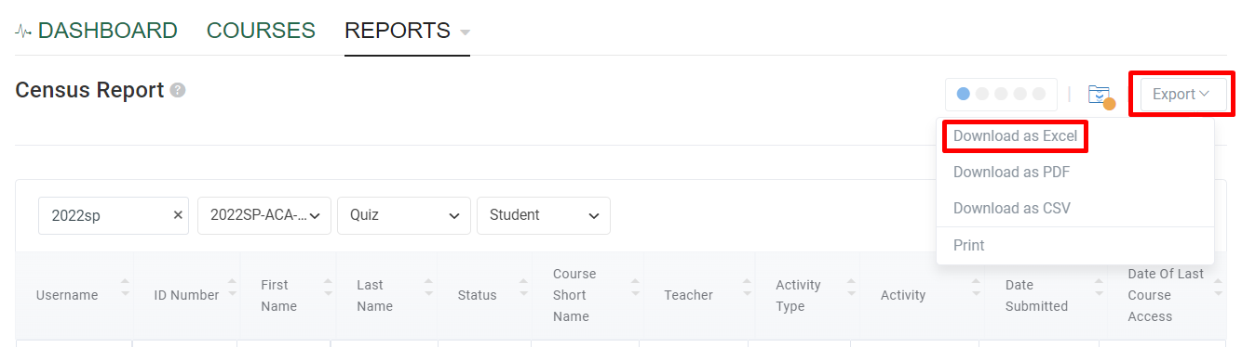

Note: If the Export files window does not pop up, click the folder icon next to the Export button.

Step 6: After the download is complete, click the Census Report in the Export file window to open it in Excel.

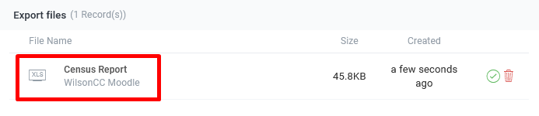

Step 7: This will open an Excel file with all of the courses you are teaching this semester. You may need to sort this by “Course Shortname” and then by “Last Name” to get your classes in alphabetical order.

Sorting instructions for Excel: highlight all of the columns, go to the “Data” tab, click “Sort”, check “My data has headers”, sort by “Course Shortname”, click “Add Level”, for ‘then by’ select “Last Name” and click “OK”.

Step 8: Use the “Date Submitted” column as the enrollment (E) date for your roster in WebAdvisor.
Step 9: Additional instructions will be distributed by the curriculum or continuing education office.

