Moodle Census Reporting Guidelines for NT, HY, and BL Courses

How to View Census Data from the IntelliBoard Instructor Dashboard
- This process works best using the Chrome browser.
- Must be done for each NT, HY, and BL course.
- These instructions are for reporting census data from the standard Enrollment Verification Quiz in Moodle.

Step 1: Log into Moodle

Step 2: Click the IntelliBoard Instructor Dashboard link.

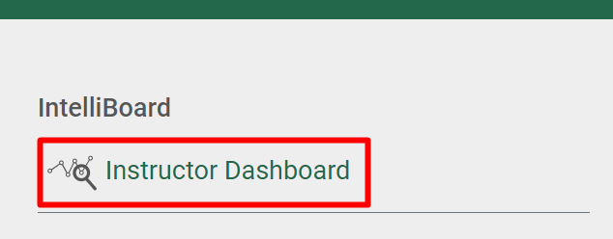

Step 3: Click Reports, Census Report.

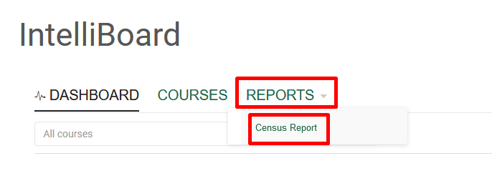

Step 4: Change the criteria as indicated below for each outlined box.

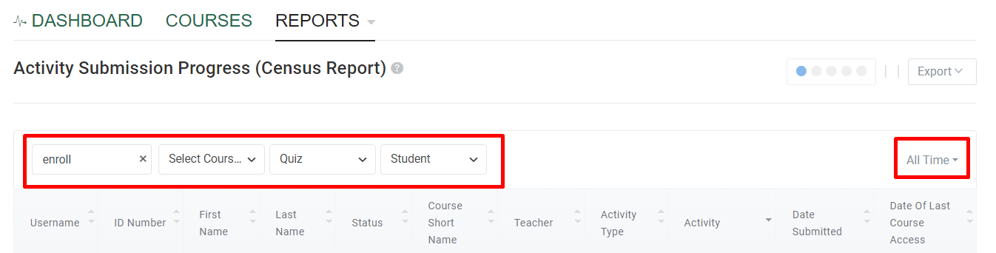

- Box 1 Search = type ‘enroll’ to filter only quizzes containing that word
- Box 2 Select Course = ‘check’ the current semester to display courses you are teaching
- Box 3 Select Activity = Quiz
- Box 4 Select Role = Student
- Box 5 Select Date Range = All Time

Step 5: Click Export, Download as Excel.

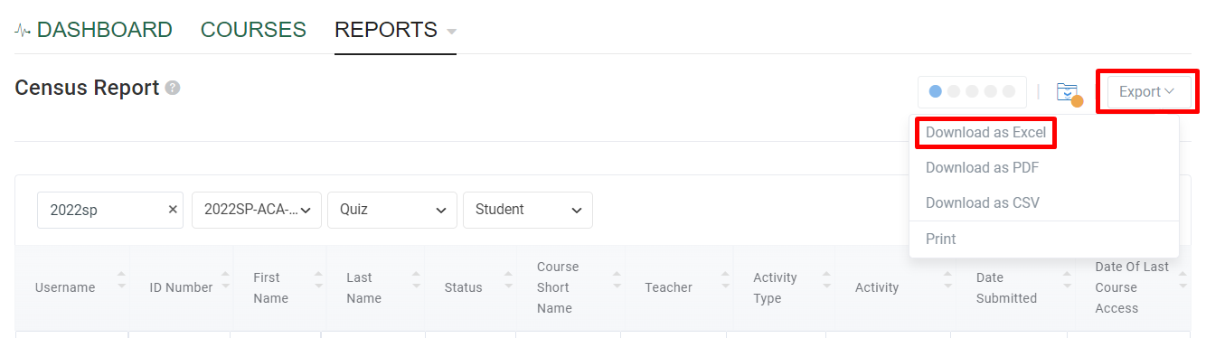

Note: If the Export files window does not pop up, click the folder icon next to the Export button.

Step 6: After the download is complete, click the Census Report in the Export file window to open it in Excel.

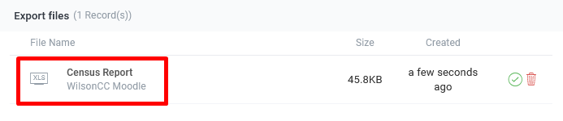

Step 7: This will open an Excel file with all of the courses you are teaching this semester. You may need to sort this by “Course Shortname” and then by “Last Name” to get your classes in alphabetical order.

Sorting instructions for Excel: highlight all of the columns, go to the “Data” tab, click “Sort”, check “My data has headers”, sort by “Course Shortname”, click “Add Level”, for ‘then by’ select “Last Name” and click “OK”.

Step 8: Use the “Date Submitted” column as the first date of attendance for your roster in Student Planning (indicated by a P for present). See the Student Planning Attendance and Grading Manual for more information on entering attendance information in Student Planning.

