Moodle Quizzes

In Moodle, the Quiz activity is used for a variety of activities. Your instructor may refer to this as a quiz, test, or exam. All Quiz activities function in similar ways.

Why take online quizzes?
Students in online classes will have online quizzes, however you may be surprised to learn that many instructors in face-to-face, hybrid, and web-supported classes also require that students complete quizzes online. There are several advantages to this:
- Classroom time is limited. By moving a test out of classroom time, your instructor has more time to engage with you as a student. You will have more time for content, more time to ask questions, and more time in the classroom devoted to you.
- Quizzes often provide immediate feedback. When an instructor creates a quiz in Moodle, he or she has to identify the correct answer. This means that, in many cases, your grade on a quiz is available immediately after you finish. You don't have to wait until the instructor returns a quiz to you in class to know how you've done.
- Multiple attempts are possible. Since the quiz is not taking up classroom time, an instructor may choose to allow multiple attempts on a quiz. If so, after getting a grade on a quiz, you may have the option to retake it for a potentially higher score. This gives you time to review content and try again.
- Missing class may not equate to missing out on a quiz. Moodle quizzes do not necessarily have to be taken at a specific date and time (unless it is required by your instructor to complete it in class). If you miss class, you can still take the quiz for that day in Moodle.

How to take a Quiz
To open a quiz click on the name of the quiz.
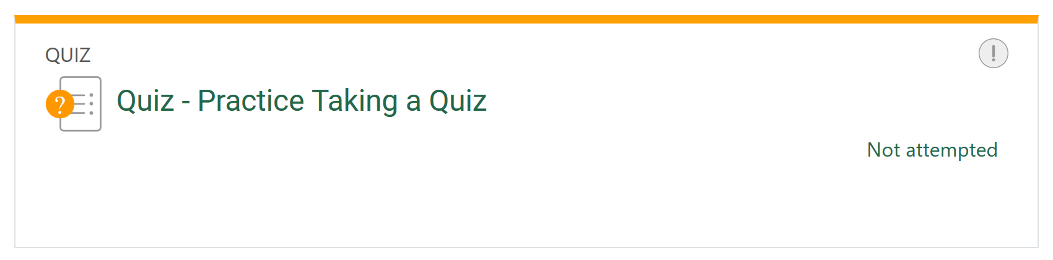

There are several screens associated with a quiz; below is a guide to interpreting these screens:
Instructions
When you first click on a quiz, you will be presented with any instructions your instructor has provided for taking the quiz.
To begin the quiz, review the instructions, and click the Attempt quiz now button.
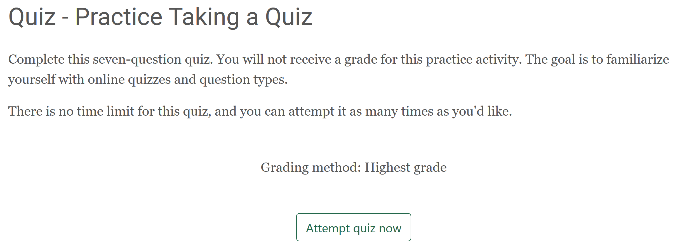
Quiz Attempt
This screen is where you answer quiz questions.
Some quizzes may only have one page of questions, while others may have several. At the bottom of each page there will be a button labeled either Next Page or Finish Attempt. The Finish Attempt button will always be found on the last page of the quiz. You can go back to previous questions using the Previous Page button.
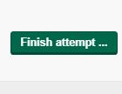
There may be a quiz navigation box at the bottom of the screen where you can jump to specific quiz questions. This will allow you to go to different quiz questions at any time, instead of in sequential order. Not all quizzes offer this, settings are determined by the instructor.
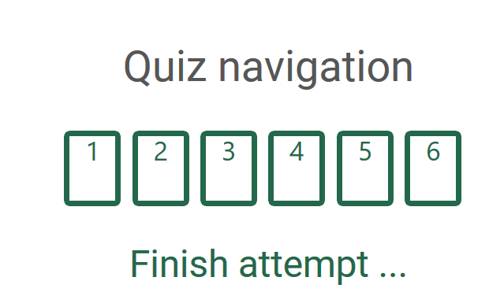
If you are unsure about a question, you can flag the quiz question to mark it as one you need to return to later. Once you have flagged a quiz question, you will see a red flag icon beside that question. This allows you to easily return to flagged quiz questions once you have responded to all remaining questions.
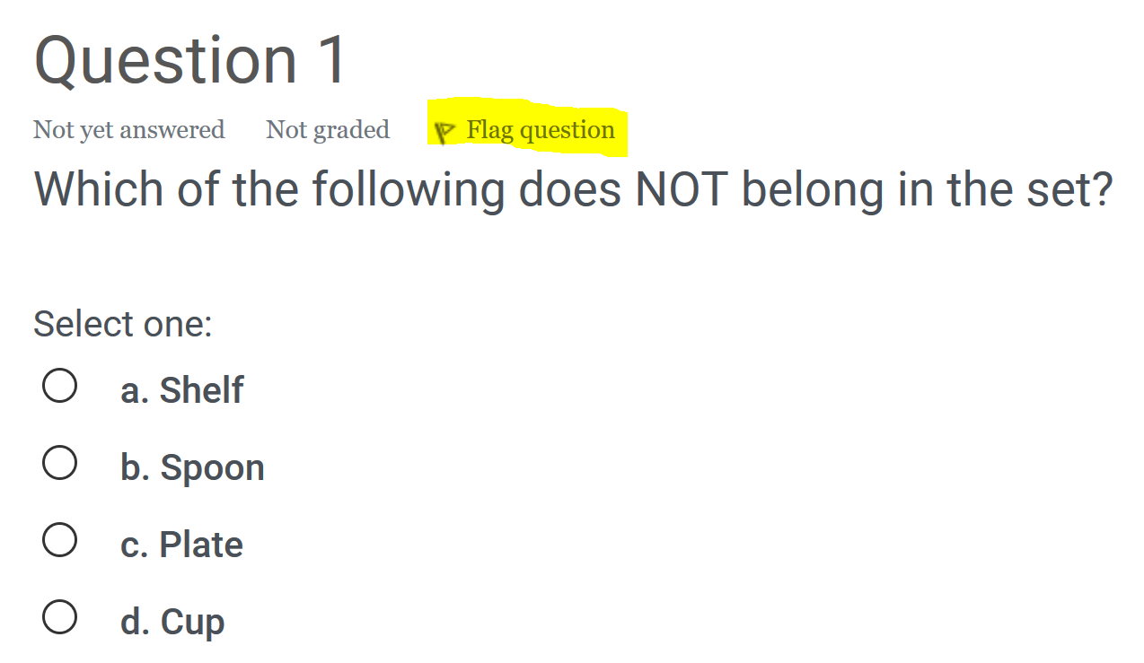
Summary of Attempt
Once you have clicked the Finish Attempt button, you will be taken to a screen which will give you a summary of your attempt.
From this screen, you can easily see if you have left any questions unanswered. Any flagged questions will also show the flag icon as a reminder that you need to revisit the question.
If you need to revisit any questions, click the Revisit attempt button. Once you have reviewed the attempt and are satisfied with your answer choices, click the Submit all and finish button.
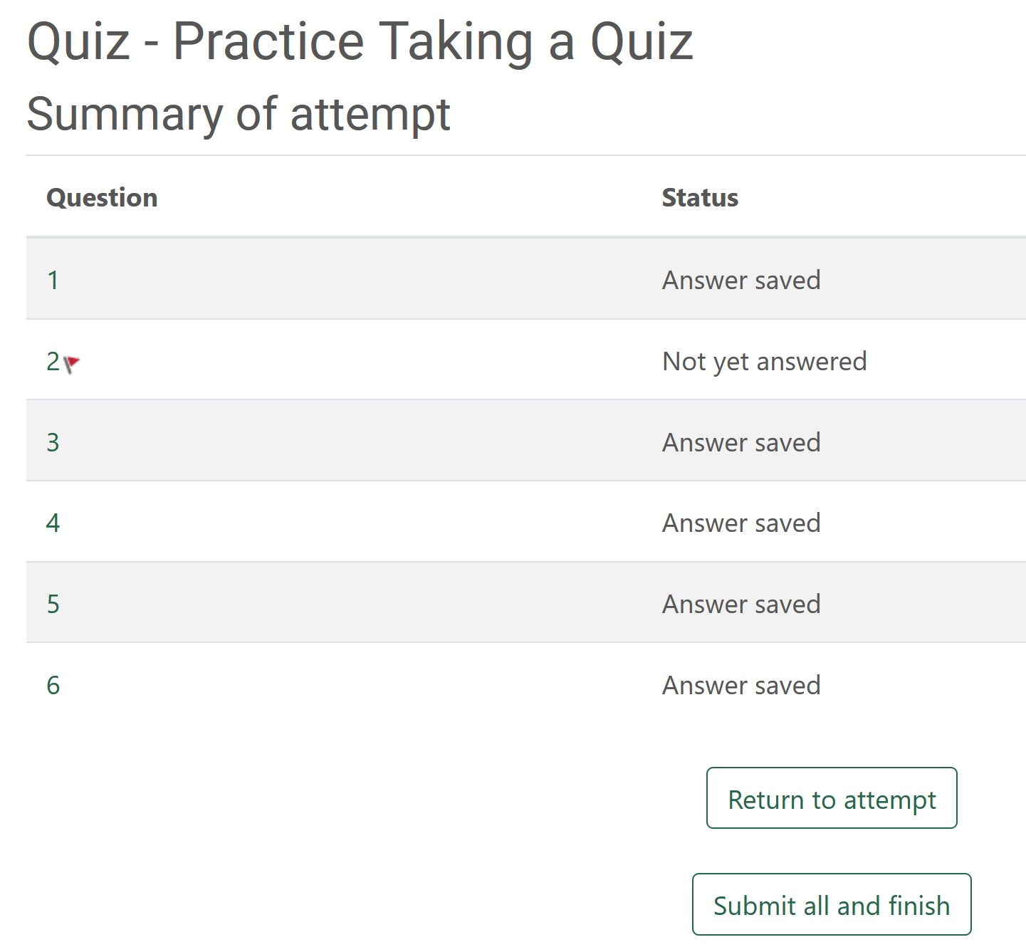
Grade
If the quiz does not contain short answer or essay questions, it will be graded automatically by Moodle. Otherwise you will have to wait for your instructor to manually grade the quiz.
You can see your grade on the next screen, as well as review your quiz attempt.
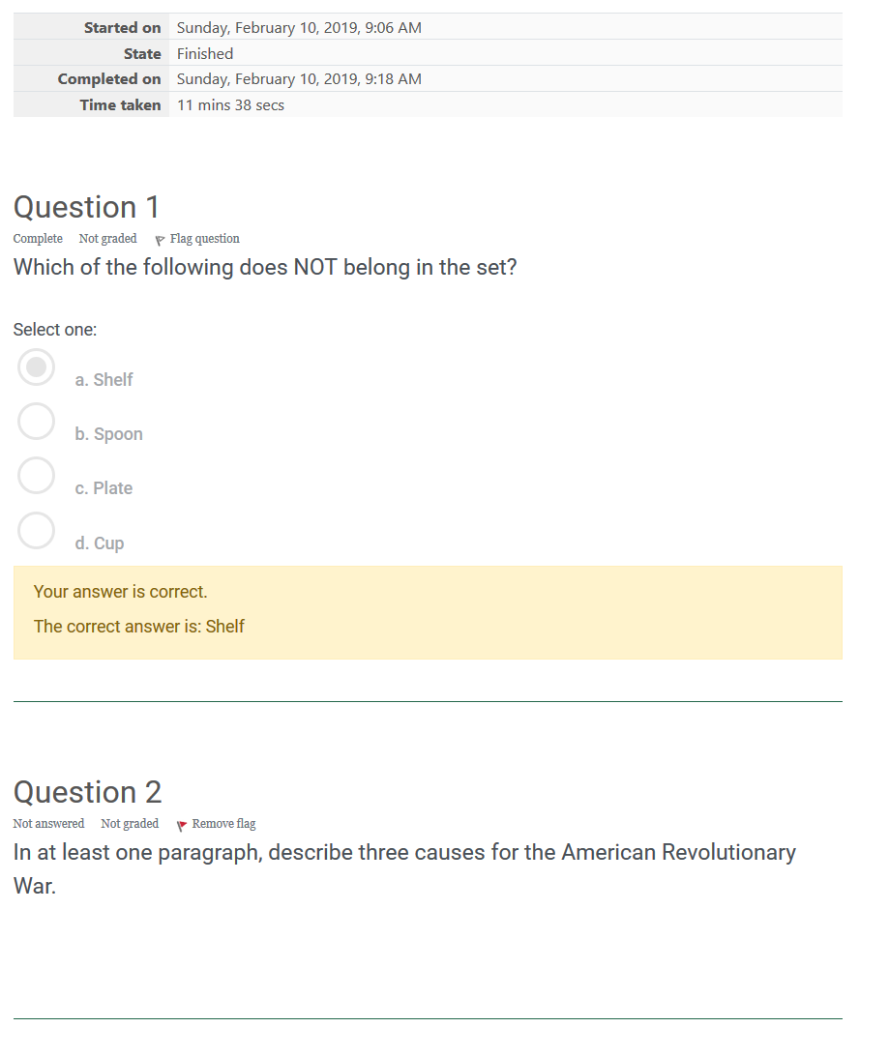
If you review the quiz attempt, depending upon quiz settings, you may see none, some or all of the following:
- Your quiz attempt
- If your answers were correct
- Your overall grade on the quiz
- Any feedback provided
- The correct answer to a question
If you are allowed multiple attempts, and you have attempts remaining, you can retake the quiz at any time prior to the quiz due date.

Question Types
Moodle Quizzes may contain any of the following types of quiz questions:
- Multiple Choice
- True or False
- Short Answer
- Essay
- Matching
Multiple Choice questions ask you to answer a question using at least one of the answers provided. There may be one correct answer or multiple answers may be correct.
Below is an example of a multiple choice question in Moodle:
To answer a Multiple Choice question, select the circle to the left of the correct choice.
If multiple answers are correct, and you can select multiple answers, then select the square to the left of each correct choice.
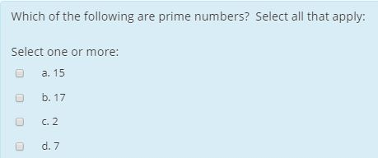
True or False questions will typically include a short statement, and you must answer whether that statement is true or false.
To answer a True or False question, select the circle beside the correct answer.
An example of a True or False question is shown below:
Short Answer questions typically include either a question or a statement, and you must write a short response. This may be one word, phrase, or a sentence.
To submit a Short Answer, type your response in the box provided. It is important to note that this type of question requires specific characters. Spelling or capitalization mistakes in your answer can cause your answer to be marked incorrect. It is very important that your answer match as closely as possible to the word or phrase expected, and double-check your response for any typos.
Unlike other types of questions, short answer questions may not be graded automatically by Moodle. If you encounter a short answer question on your quiz, understand that your quiz grade may not be available until your instructor grades your response.
Here is an example of a Short Answer question:
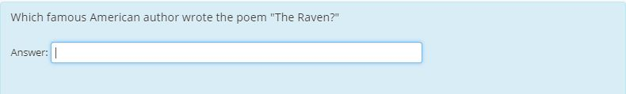
Essay questions typically involve a question, statement, or prompt, and you must write a response. The desired length of an essay may be anywhere from one paragraph to several paragraphs. Read the question multiple times to understand the expectations of your instructor.
To answer an Essay question, type your response into the text box. Be careful not to exceed the time limit, if you have a limit.
Unlike other types of questions, essay questions cannot be graded automatically by Moodle. If you encounter an Essay question on your quiz, understand that your quiz grade will not be available until your instructor grades your response.
Here is an example of an Essay question:
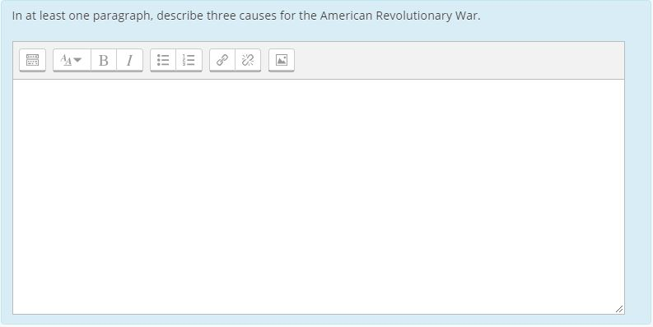
Matching questions will require that you connect two or more phrases, concepts, or items to each other.
To answer a Matching question, select the most appropriate match from the drop-down box located to the right of each item.
It is important to note that Matching questions are often not accessible to screen-readers. If you use this technology and require accommodation, contact your instructor to make arrangements for an alternate option.
Here is an example of a matching question:

