Moodle Tools for Student Engagement

Check out the following tools to increase student engagement in Moodle. These tools can be easily added to a Moodle course, at the “Create Learning Activity”, Activities tab.

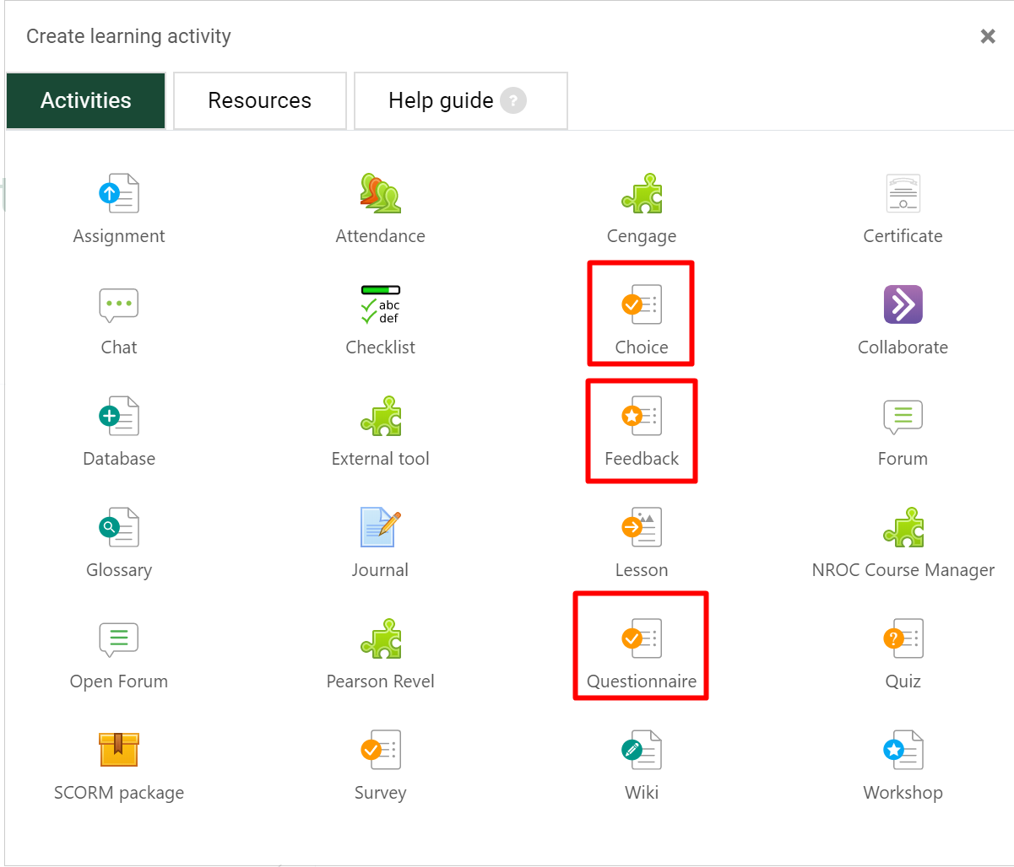

Choice - https://help.blackboard.com/Blackboard_Open_LMS/Teacher/Activities_and_Resources/Choice
The choice activity module enables a teacher to ask a single question and offer a selection of possible responses.
Choice results may be published after students have answered, after a certain date, or not at all. Results may be published with student names or anonymously.
A choice activity may be used
- As a quick poll to stimulate thinking about a topic
- To quickly test students' understanding
- To facilitate student decision-making, for example allowing students to vote on a direction for the course

Feedback - https://help.blackboard.com/Blackboard_Open_LMS/Teacher/Activities_and_Resources/Feedback/Feedback_Activity
The feedback activity module enables a teacher to create a custom survey for collecting feedback from participants using a variety of question types including multiple choice, yes/no or text input.

Feedback responses may be anonymous if desired, and results may be shown to all participants or restricted to teachers only. Any feedback activities on the site front page may also be completed by non-logged-in users.

Questionnaire - https://help.blackboard.com/Blackboard_Open_LMS/Teacher/Activities_and_Resources/Feedback/Questionnaire
The questionnaire module allows you to construct surveys using a variety of question types, for the purpose of gathering data from users.

