Navigating Moodle

My Courses
Once you log in to Moodle, the My Courses page (pictured below) will be displayed. Courses that you are enrolled in will appear as blocks. If you are a new student, or you are not enrolled in any courses during the current active semester, then the only course you may see is the Moodle-101-for-Students course.
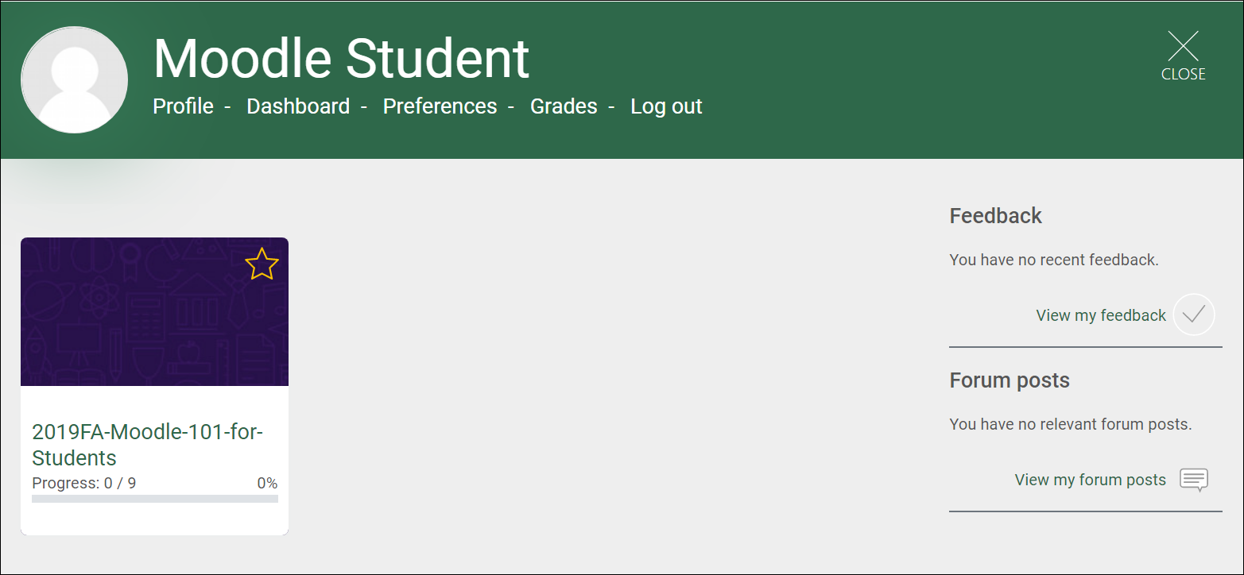

Personal Menu
The Personal Menu (pictured below) at the My Courses page provides quick access to the most commonly used features of Moodle.
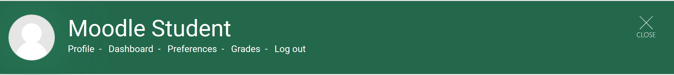
- Profile allows you to view and edit your Moodle Profile, such as adding a profile image.
- Dashboard takes you your Moodle Dashboard. This area may be blank at first, however important tools, such as course evaluations, may be added to the Dashboard later.
- Preferences allows you to view and edit various Moodle settings. The default settings are normally sufficient for most users.
- Grades allows you quick access to the course average and the gradebook for each course you are currently enrolled in.
- Log out logs you out of Moodle.

Click My Courses (highlighted in the image below) to return to this page from anywhere in Moodle.

Moodle Site Home
Clicking the close button in the top right corner of the My Courses page will take you to the Moodle Site Home page (pictured below). If the close button does not take you to the Moodle Site Home page, click the Wilson CC/Moodle logo at the top of the page.
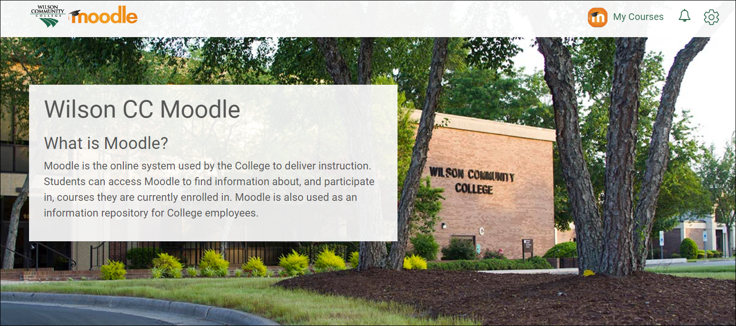
Scroll down to find the links to complete Course Evaluations and Online Tutoring. Below that, you will find the footer (area with gray background in the image below) which has a lot of useful resources to assist students. Explore all of the links to become familiar with what is available.
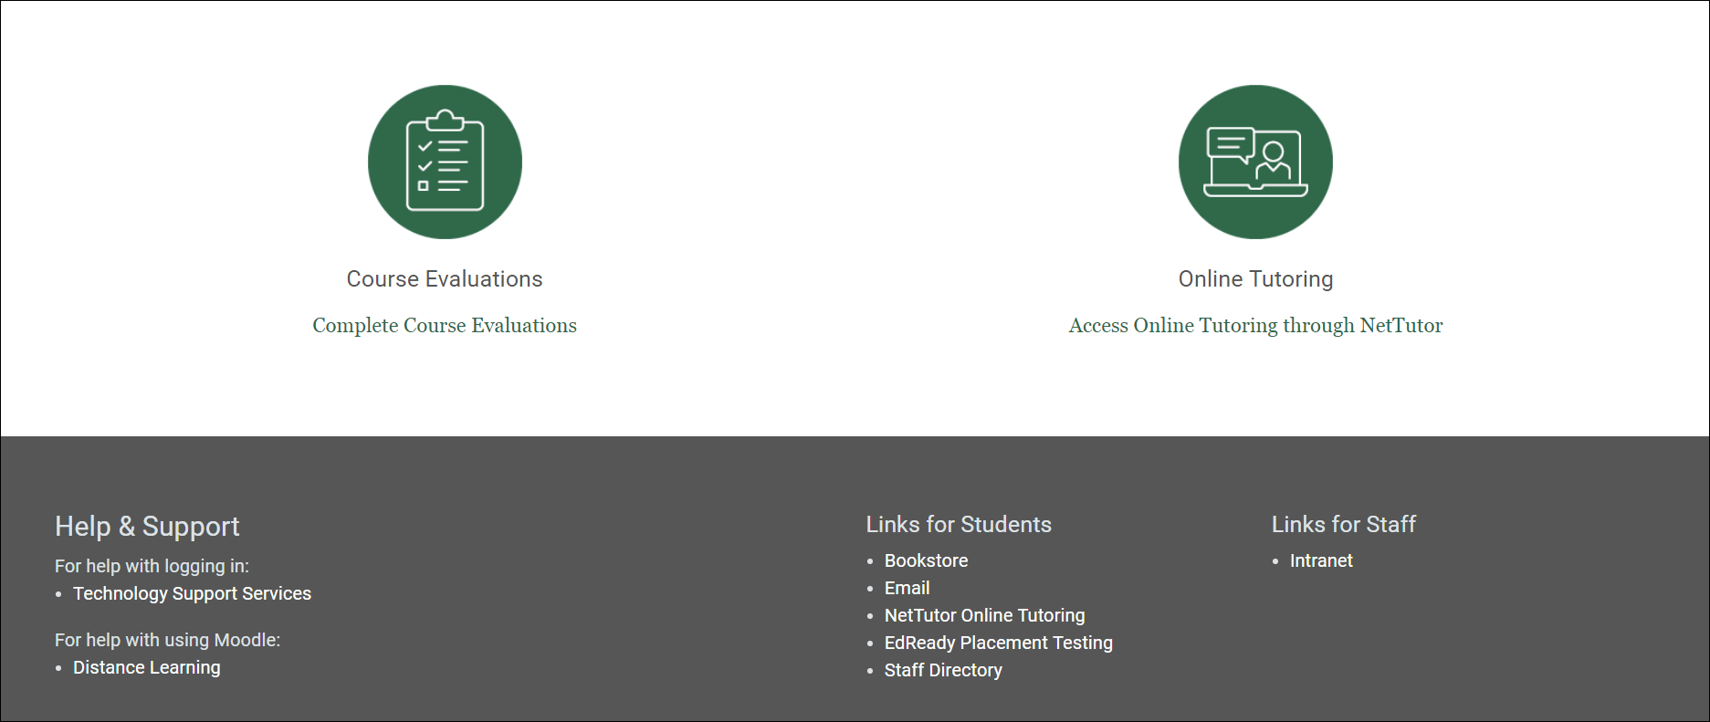

Accessing Courses
To enter a course, click on the block for that course from the My Courses page (pictured below).
Clicking a course block will take you to the homepage of the course (example course pictured below).
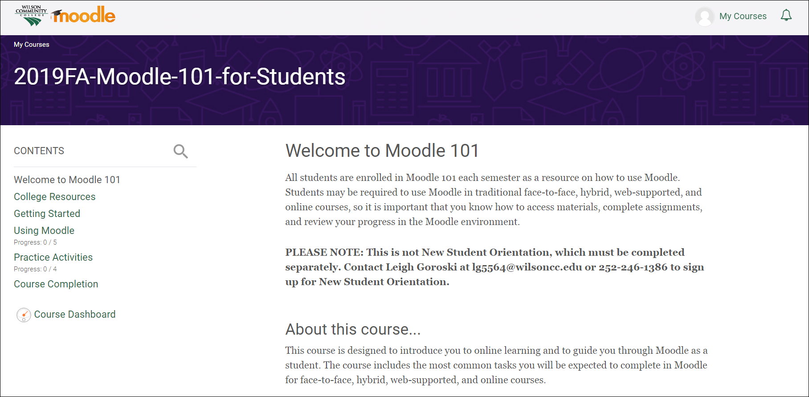

Navigating a Moodle Course
The Contents (outlined in the image below) on the left side is main navigation for the course. When you click on a topic in the Contents, the information in that topic will be displayed on the right. It is important that you read the information in each topic and follow any instructions provided by your instructor. Note that you may have to scroll to see all of the information provided.
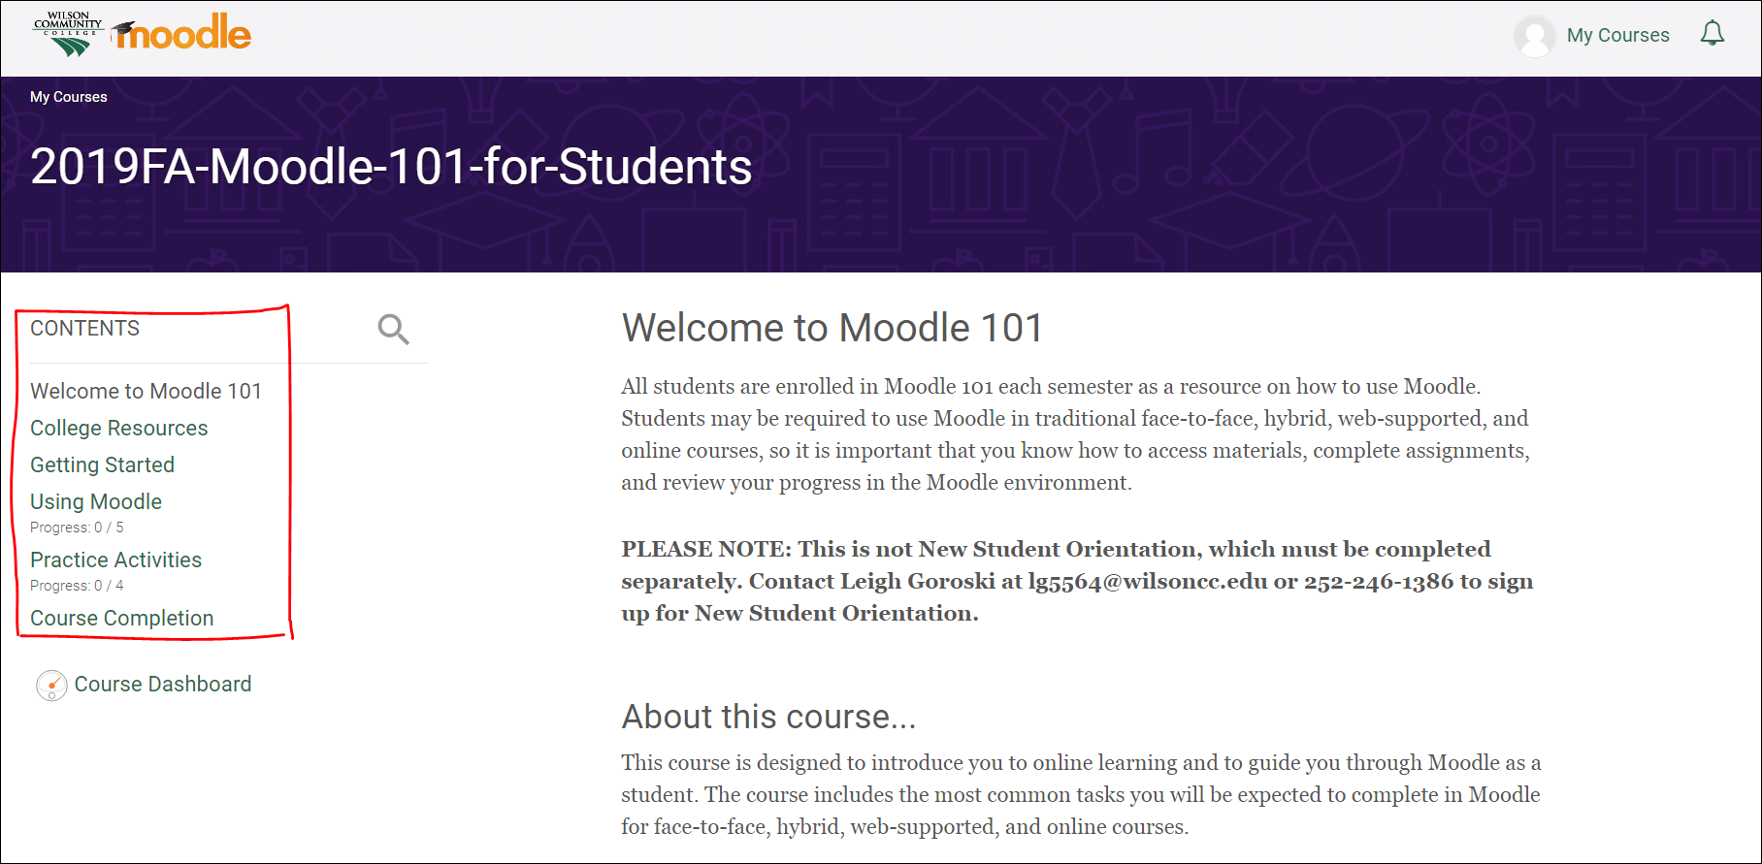

Breadcrumb Trail
Once you are in a Moodle course, and you have navigated to a particular section in the Contents, you can use the breadcrumb trail (see arrow in the image below) to navigate back to previously visited sections within the course, or you can click the course name to get back to the course home page.
