Personalized Learning Designer (PLD)
Personalized Learning Designer (PLD) is a feature in Moodle which allows instructors to perform automatic actions to students when specified conditions are met.

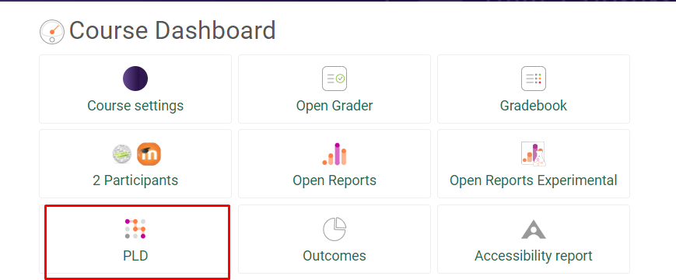

You can set up rules ahead of time that will automatically cause an action (an alert or email) to be sent to your students under certain conditions using PLD in your Moodle course.
A short resource course is available in Moodle to help you learn how to create and use PLD. If you would like to be enrolled in this course, please send your request to Kelly Ellis.
What are 'Rules'?
'Rules' are the automatic actions instructors can instruct PLD to perform. Each rule is made up of events, conditions and actions.
- Events - Determines when the rule is run. (e.g. at a date/time or when a user views a page)
- Conditions - Determine who will be affected by the rule. If no conditions are set, the rule will affect everyone related to the event. (i.e. affects students only)
- Actions - Determines what happens when the rule is run. (i.e. send an email)
Can the PLD rules be personalized for each student?
Yes, PLD rules can be set to automatically include each student’s individual name in the
alert or email, the name of a specific activity, and much more.

Would I have to recreate the rules every new semester?
No, each rule you create will remain in place when you backup and restore a course unless
you delete them. PLD rules can be added and deleted at any time during the semester.

Examples of ways to use PLD in your course:
- One or more students received a low score on a graded activity.
You can have an automatic alert or e-mail sent to them with their individual name in the alert or email to personalize it. You can set the rule to occur for all activities of a certain type such as all
quizzes, or just one specific graded quiz activity.

- A student (or students) did not complete an activity by the due date.
You can send an automatic alert/e-mail to them explaining what they should do.

- A student (or students) forgot to reply to a forum post.
You can have an automatic reminder sent to them.

- There are students not logging in often. You can have an automatic email to them (and
a CC to your email if desired) every x days.

- You have an assignment that could be difficult for some students, especially if they didn’t take time to cover some important material in the textbook. If they make a poor grade (less than a 70 for instance) you want to encourage them to go back to certain pages in the textbook to do more review before they complete a major quiz partially based on that information.

- Create an automatic pop-up message to encourage students to do well when they get ready to take a quiz.

If you set up a PLD to send an email to your students, please be sure to check the box that will exclude all suspended (not current) students from the email.
