Padlet Video Assignment
How-to

- In your Moodle course, click on the URL provided (you may need to click to open in a new tab/window).
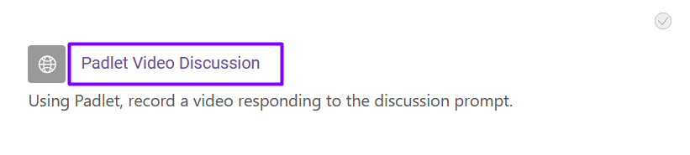

- Once wilsoncc.padlet.org opens, you may be required to sign up/in if you haven’t done so before. Click on the avatar to go to the login or continue using your Microsoft 365 credentials.

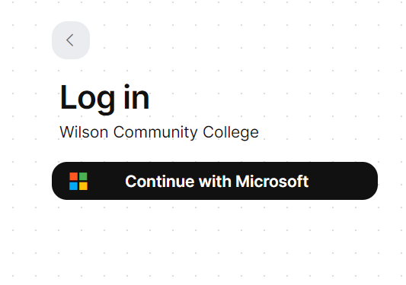

- Once successfully logged in, you’ll be redirected to the Padlet your instructor created. Check for any instructions on the Padlet, and when you’re ready to post, click the “+” button to post, and the posting options will pop up.

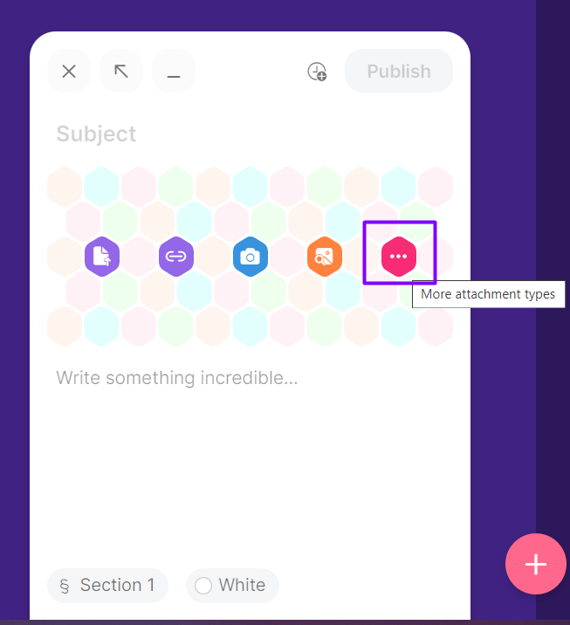

- To record a video, choose “More attachment types,” and you’ll see “Video Recorder” as an option.

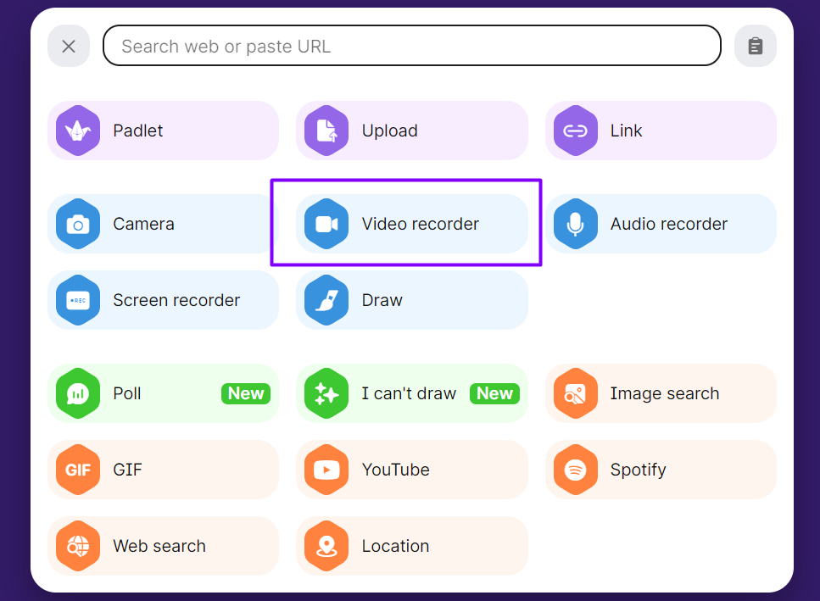

- Once it is available and you’re ready to record, click on the camera icon. When you’re finished, click the pause button.

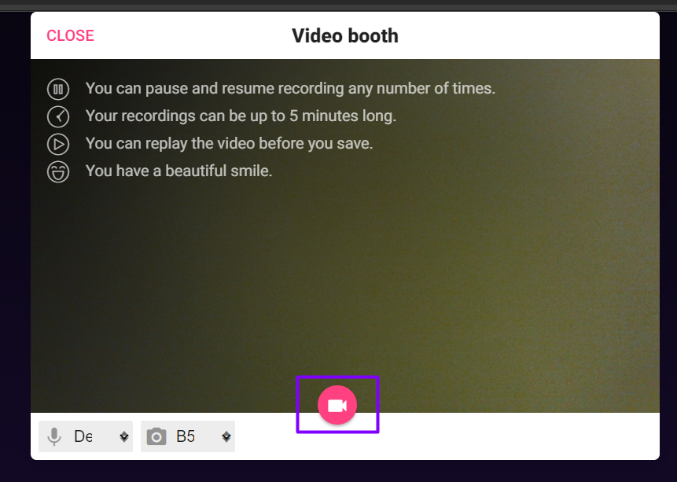
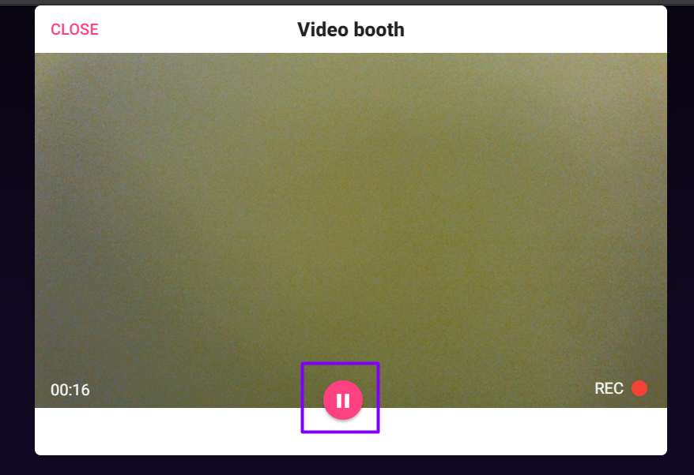

- You’ll have the option to review the video and save or discard and restart it. Once you’re ready to save, you’ll have the opportunity to name your video. Choose “Save.” Once the video is fully uploaded, you can name the post and write any content needed to complete the assignment. When finished, click “Publish” to submit.

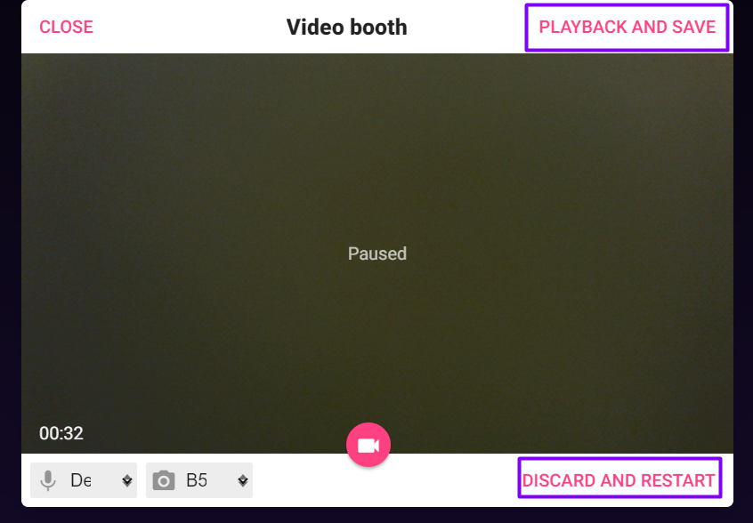
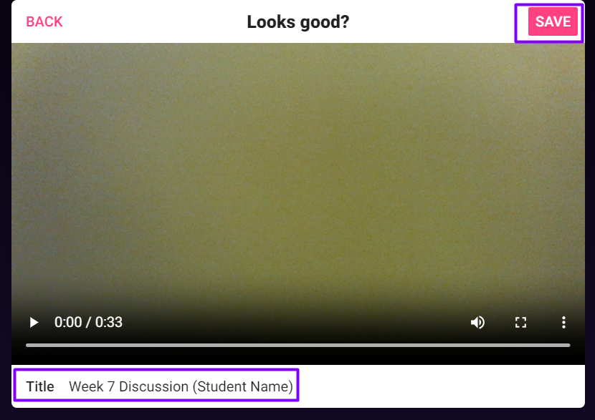
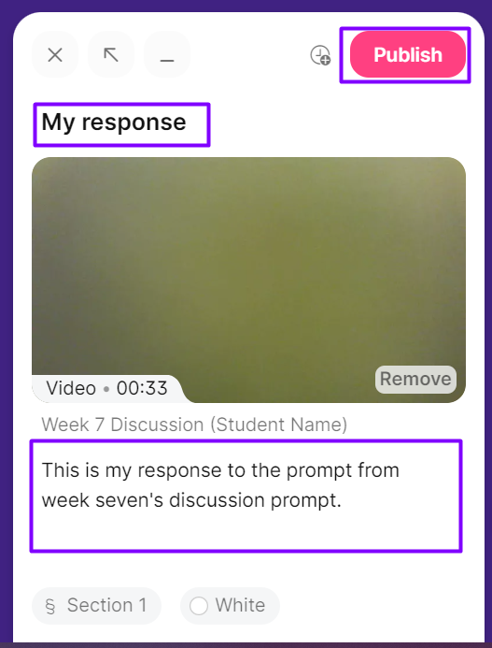

7. Your post is immediately available for instructor and/or peer view (depending on instructor settings).

