Site Navigation
When users first arrive at our Moodle site, they are viewing the front page, or home page.
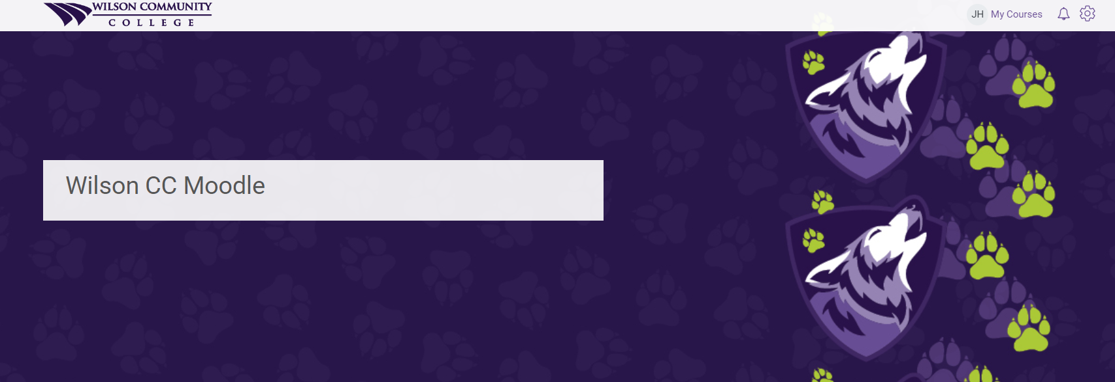

My Courses
Once a user logs in, they will be presented with their My Courses page.
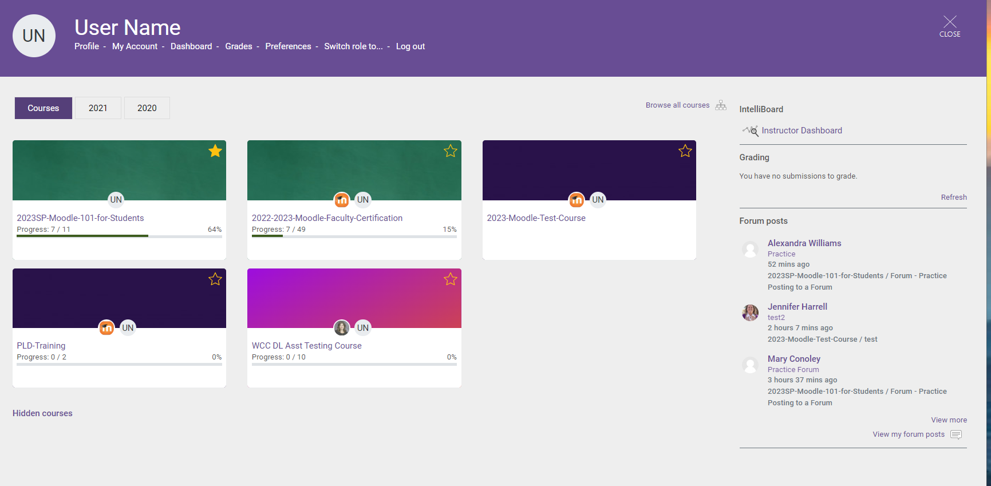
Faculty should see the Intranet and any past, present, or future courses they were/are assigned to teach.
Hint: Clicking the “star” for a course makes it a favorite, and it will appear at the top of your course list.
Hint: If you do not see the course(s) you are looking for, click the Hidden courses link to see all courses you have access to.

Hint: Check the year tabs to see tabs from previous years.
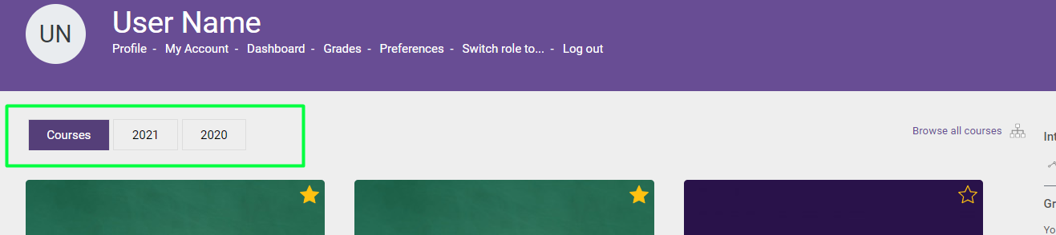

Personal Menu
The Personal Menu (pictured below) at the My Courses page provides quick access to the most commonly used features of Moodle.
- Profile allows you to view and edit your Moodle Profile, such as adding a profile image.
- Dashboard takes you to your Moodle Dashboard. This area may be blank at first, blocks may be added to the Dashboard later.
- Grades allows you quick access to the gradebook for each course you are currently enrolled in or teaching.
- Preferences allows you to view and edit various Moodle settings. The default settings are normally sufficient for most users.
- Log out logs you out of Moodle.

Moodle Site Home
Clicking the close button in the top right corner of the My Courses page will take you back to the Moodle Site Home page (pictured below). If the close button does not take you to the Moodle site home page, click the Wilson CC/Moodle logo at the top of the page.
Scroll down to find the links for students to complete Course Evaluations and Online Tutoring. Below that, you will find the Search Courses box and the footer area, which has a lot of useful resources to assist students. Explore all of the links to become familiar with what is available.
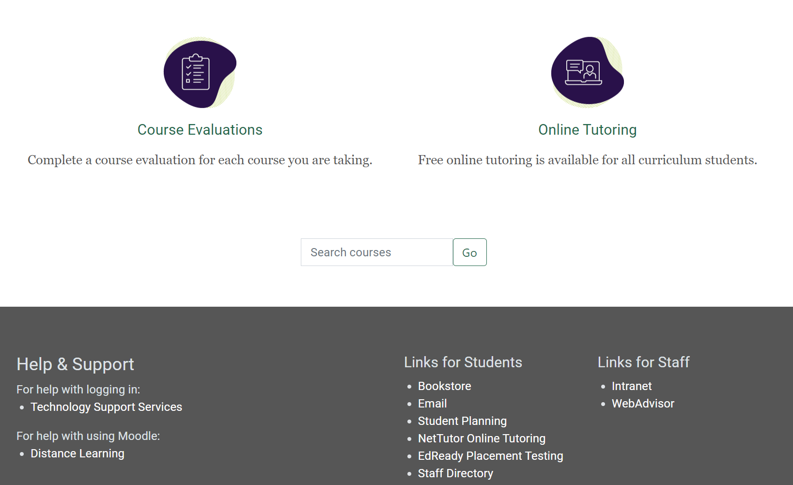

Search Courses
The search courses box will allow you to quickly find the course you are looking for (this is especially helpful if you have multiple semesters of courses in Moodle). All courses start with the semester name, so to see just courses from a particular semester, you could search "2023SP." You will only be able to see the courses that you have access to in Moodle.

