Using SafeAssign in Moodle
SafeAssign is a plagiarism prevention tool that works with Blackboard Open LMS 3.3 and above and integrates with Moodle’s established plagiarism plugin framework. SafeAssign is based on a unique text-matching algorithm capable of detecting exact and inexact matching between a submitted paper and source material. Results are returned in the Originality Report.
SafeAssign’s overall Originality Score for a student’s submission and a link to the Originality Report generated by SafeAssign appear in Moodle’s Assignment Grader and the Open Grader.
SafeAssign Originality Score in Assignment Grader
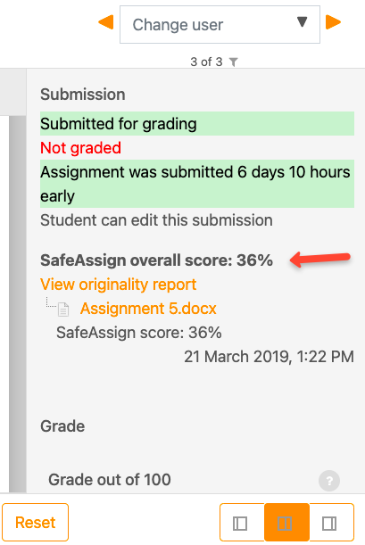

Selecting 'View originality report' launches the SafeAssign interface where you can view the more detailed Originality Report Summary.
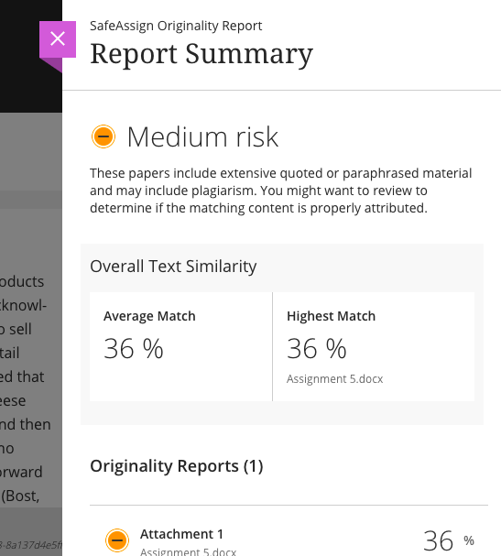

Creating a SafeAssign Assignment
At this time, the SafeAssign plugin is only compatible with Moodle’s Assignment Activity. To create a SafeAssign assignment, start by creating an assignment. In the assignment settings, choose your SafeAssign settings.
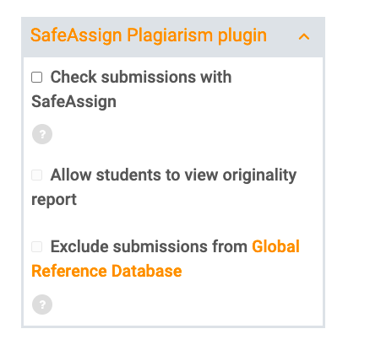
SafeAssign is a paid add-on for Blackboard Open LMS. Please contact your site administrator if you do not see the SafeAssign Plagiarism plugin options in assignment settings.
- Check submissions for plagiarism: Select this option to check the student submissions with SafeAssign.
- Allow students to view originality report: Select this option to allow students to view their originality report from the assignment submission. This option provides a link to the report.
- Exclude submissions from institutional and Global Reference Database: Select this option to allow submissions to still be processed by SafeAssign but not registered in databases. This avoids submission files being marked as plagiarized when teachers allow re-submissions in a specific assignment.
Select Save and return to course or Save and display when finished.

Access the report
View the SafeAssign Originality Report to ensure students properly cited their sources.
SafeAssign generates an Originality Report shortly after a student submits their attempt, even before you post grades. The SafeAssign Originality Report appears next to the submission so you can view the analysis in context. This is a preview of the report’s results and includes three sections: Overall Risk, Overall Text Matching, and Originality Reports.
- Overall Risk shows whether the attempt is a low, medium, or high risk for plagiarism. The risk level is determined based on the average text matching range the attempt falls in.
- Overall Text Matching shows the average and highest text match for the pieces of the attempt, including file attachments. Want to dive in? Select any of the items in the Originality Reports section to view the full reports.
- Originality Reports shows you the percent of potential matching text for each piece of your submission, including questions and attachments. Select any of the entries in the list to view the results in a new window.

Report layout
A SafeAssign Originality Report is divided into three areas:
- Report information
- Citations
- Manuscript text
If you need more room for viewing the paper’s text, you can collapse the right panel with the right-pointing arrow. The highlighting colors remain in the collapsed view.
Report information
Report information appears in the right panel of the report. When you reduce the width of the viewing area, this information appears at the top. You can view data about the paper, such as the percent of matching text, word count, and when it was submitted. If you included multiple attachments, they appear with the report information. You also have an option for viewing a printable version. This printable version is the most effective view of the report for users who rely on assistive technology to access Blackboard Open LMS. At the top of the page, select Print to view the printable version. Download the PDF to email to others.
Citations
The sources that include text that matches the submitted paper’s text are listed in the right panel of the report. If Another student’s paper is listed as a citation, the submission is associated with another institution and you may not be able to view it due to privacy laws.
Manuscript text
The submitted paper appears in the left panel of the report. All matching blocks of text are identified. Each source has a color specific to the source-up to 30 unique colors for 30 different sources. Text matching a source is highlighted in the source color and identified with a number. In the right panel, you can select Show/Hide All Highlighting to turn source highlighting off and on for all sources at one time. You can turn the highlighting off and on for only one citation. Select Remove or Show Highlighting next to a citation.
Select a matching block of text to display information about the original source and the probability that the block or sentence was copied from the source.

Multiple attachments and attempts
SafeAssign recognizes multiple attempts for an individual assignment as submitted by the same student for the same assignment. SafeAssign doesn’t check the contents of the current attempt against content from previous submissions. You can view each Originality Report next to the corresponding attempt.
If a student includes more than one attachment with an assignment, they are listed in the Originality Report section of the SafeAssign panel. Select a file name link to view the file’s text in a new window, along with detailed text matching analysis.

Multiple role assignments
Moodle allows users to have more than one role assigned to them. SafeAssign can’t associate multiple users with the same id as instructors and students, so multirole submissions with SafeAssign don’t work. To fix this, the SafeAssign plugin will not analyze a multi-role user submission and will warn them about it.
Users with role assignments set at the system level: Manager, Course creator, etc., are added by default to each SafeAssign course as instructors.

Interpret SafeAssign scores
Sentence matching scores represent the percentage probability that two phrases have the same meaning. This number reflects the reciprocal to the probability that these two phrases are similar by chance. For example, a score of 90 percent means that there is a 90 percent probability that these two phrases are the same. There is a 10 percent probability that they are similar by chance and not because the submitted paper includes content from the existing source-whether appropriately attributed or not.
The overall SafeAssign score indicates the probability that the submitted paper contains matches to existing sources. This score is a warning indicator only. Review papers to see if the matches are properly attributed.
- Scores below 15 percent: These papers typically include some quotes and few common phrases or blocks of text that match other documents. Typically, these papers don’t require further analysis as there is no evidence of plagiarism.
- Scores between 15 percent and 40 percent: These papers include extensive quoted or paraphrased material, or they include plagiarism. Review these papers to determine if the matching text is properly referenced.
- Scores over 40 percent: A very high probability exists that text in these papers was copied from other sources. These papers include quoted or paraphrased text in excess, and need to be reviewed for plagiarism.

