View Bookstore info from Student Planning
- Go to Student Planning at https://ss.wilsoncc.edu:8173/Student and login.
- Click “Course Catalog”.
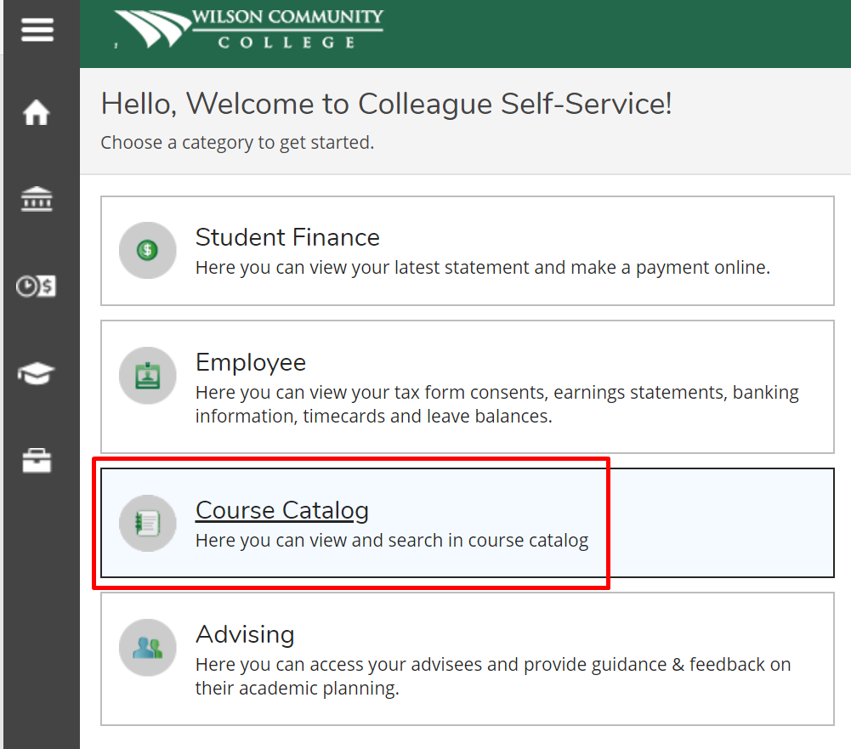
- This brings you to the course search page. In this example I will be searching for ACC 120.
- Start by clicking “ACC-Accounting”.
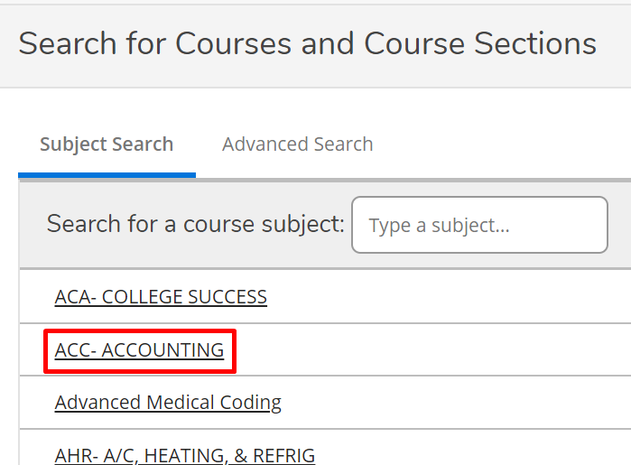
- Click “View Available sections for ACC-120”
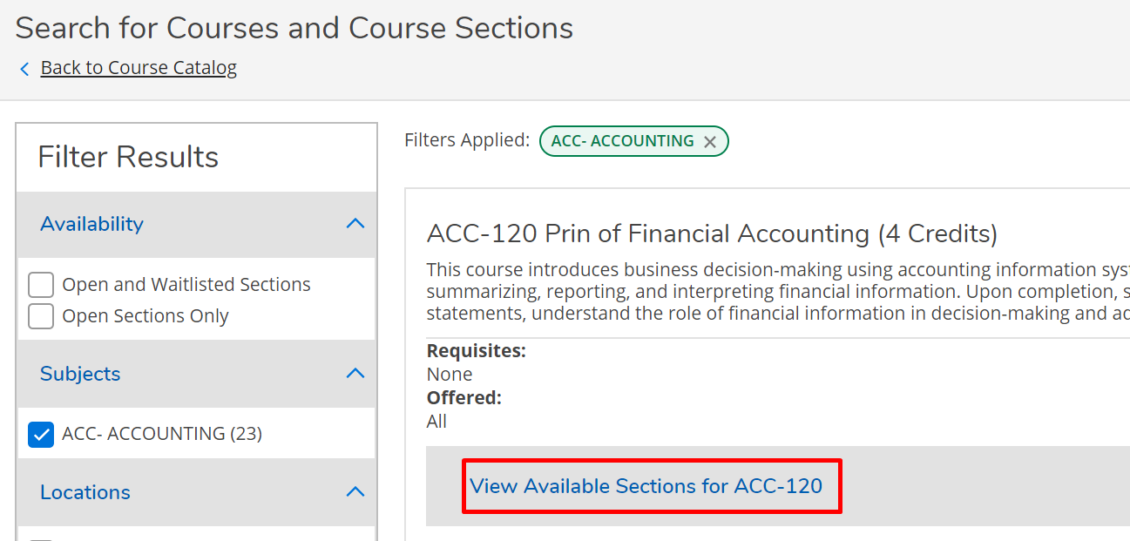

- Click on the desired section.
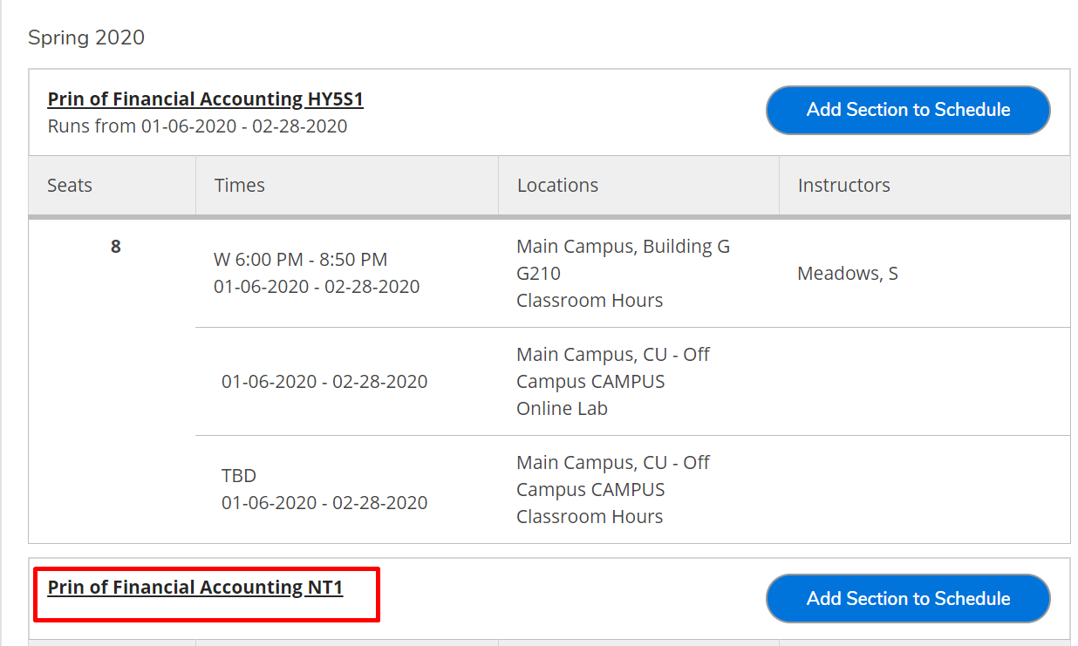
- At the Section Details screen, click “Bookstore Information”.
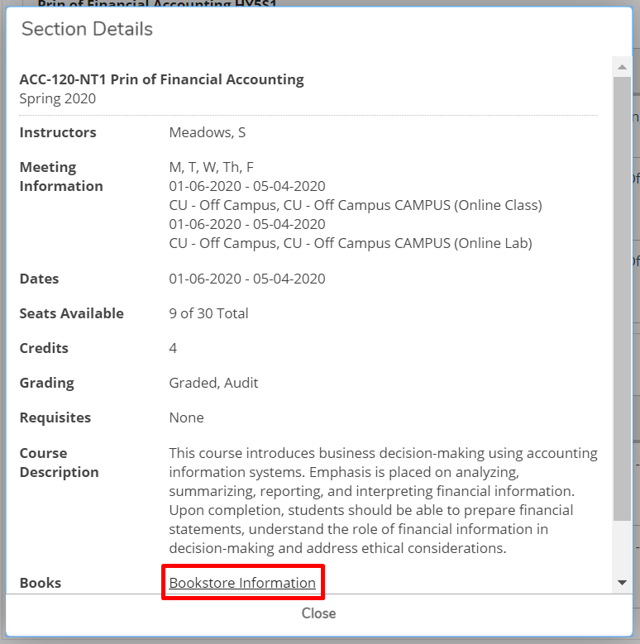
- This takes you to the Bookstore website, scroll down to view all of the available textbook options for the course and section you selected.
