Viewing Grades in Moodle

Viewing Grades from the My Courses Personal Menu
You can view your current average in all of your courses from the My Courses Personal Menu by clicking the Grades link.
Each course you are currently enrolled in will be listed, along with your current average.

Viewing Grades Within a Course
To view all of your grades in a particular course, access the course and click Course Dashboard at the bottom of the Contents list.
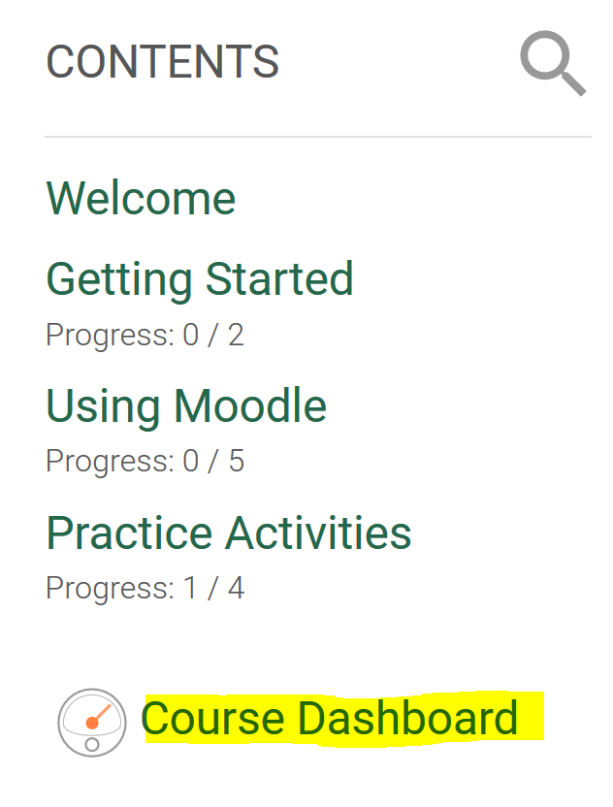

At the Course Dashboard, click the Gradebook link (circled below).
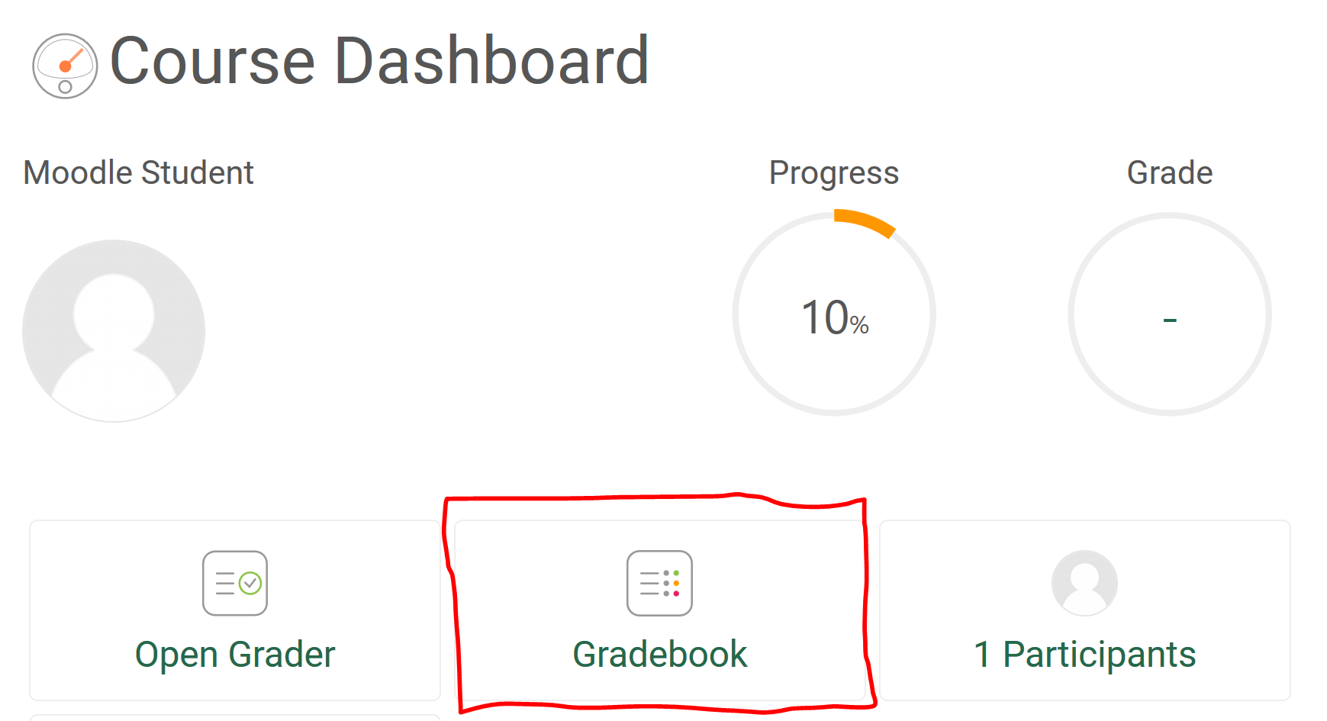
Your grades will look similar to the following image.
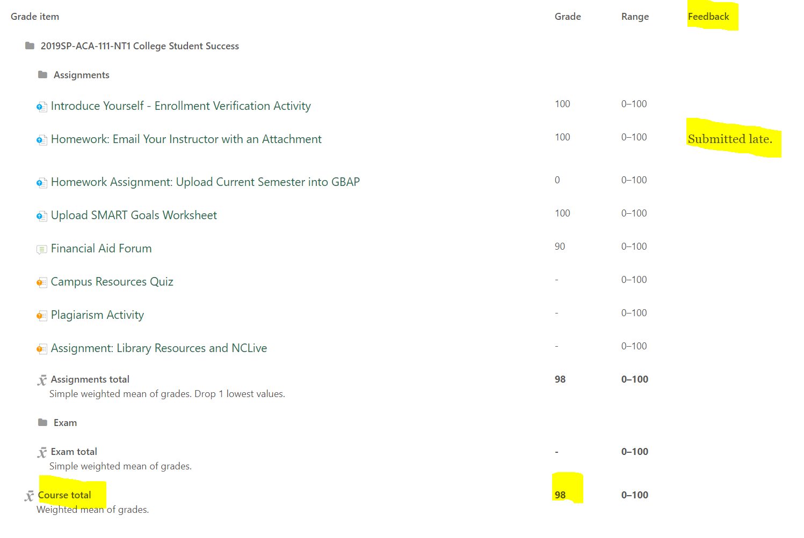
If your instructor has provided feedback, you will find it in the Feedback column.
The Course total is your current average in the course. Note that until the instructor finalizes grades at the end of the semester, the course total is simply an estimation of where you currently stand in the course.
Final grades are available in WebAdvisor and Student Planning at the end of the semester.

