NetTutor

Refer Tutor Report

Online Tutoring

Instructor Guide

What is NetTutor Refer Tutor Report?

NetTutor Refer Tutor Report, is the online tutoring product supported by the College. NetTutor allows instructors to refer students for online tutoring and track student progress by viewing referrals made and viewing reports of tutoring sessions.

How to Access NetTutor Refer Tutor Report:

- Go to Moodle at https://moodle.wilsoncc.edu and login.
NetTutor is integrated with your Moodle login, so once you login to Moodle, you are logged in to NetTutor.

- Click the NetTutor link at the top of the window.

- This will take you to the Refer Tutor Report dashboard.

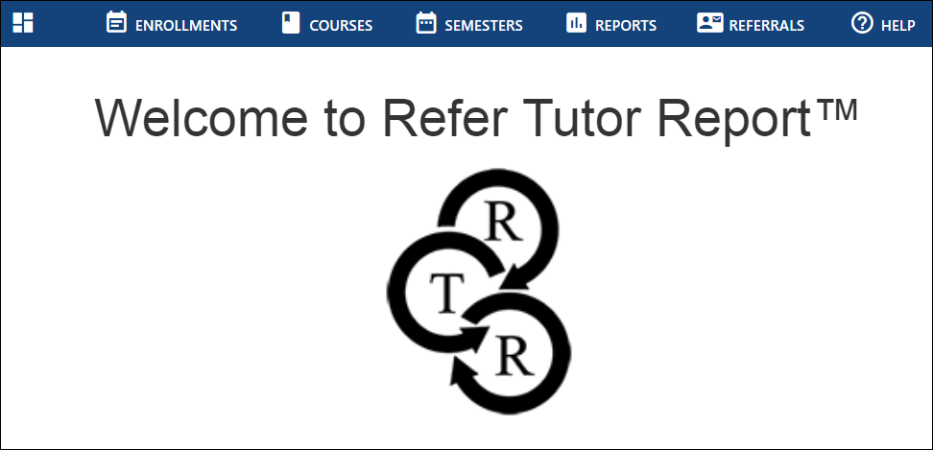

How to Refer Students:
At the Referrals tab, click the Refer A Student button.

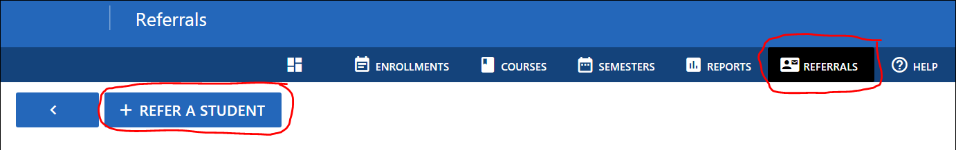

Fill in the requested information and click the Submit Referral button. Note that bulk referrals can be made by clicking the check box next to each student in the Student drop down box.

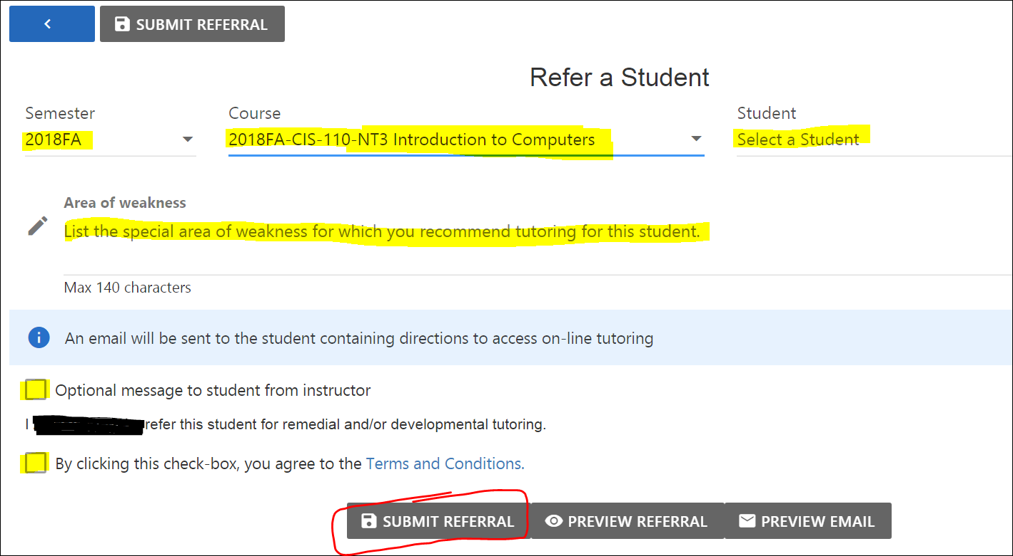

How to View Referrals Made:
At the Referrals tab you can view all referrals that you have made, or you can view the referrals for a particular course by selecting the course in the drop down area.

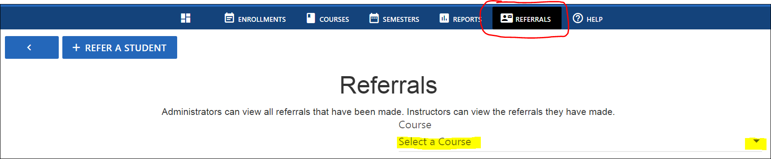

How to View Reports:
At the Reports tab, select the semester from the drop down list.

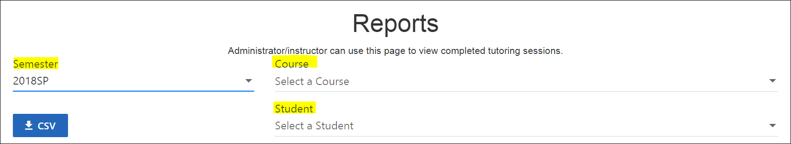

All of the tutoring sessions for the semester will be displayed. This is how you can check to see if students are following through with referrals and received tutoring!

- To view a student’s feedback from a Paper Center submission, click the “paper” icon in the Archive column.

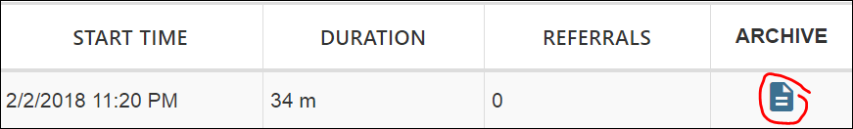

- To view a recording of a student’s tutoring session, click the “play” button in the Archive column.

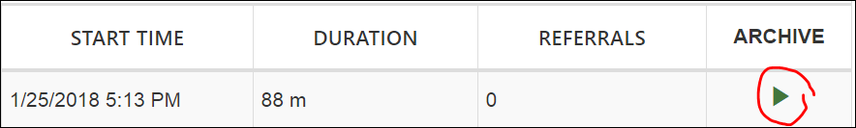

How to View Available Courses:
- At the Courses tab, select the semester from the drop down list to see all courses that you are teaching that have access to NetTutor services. In the Search box type the term using the format: 2018FA

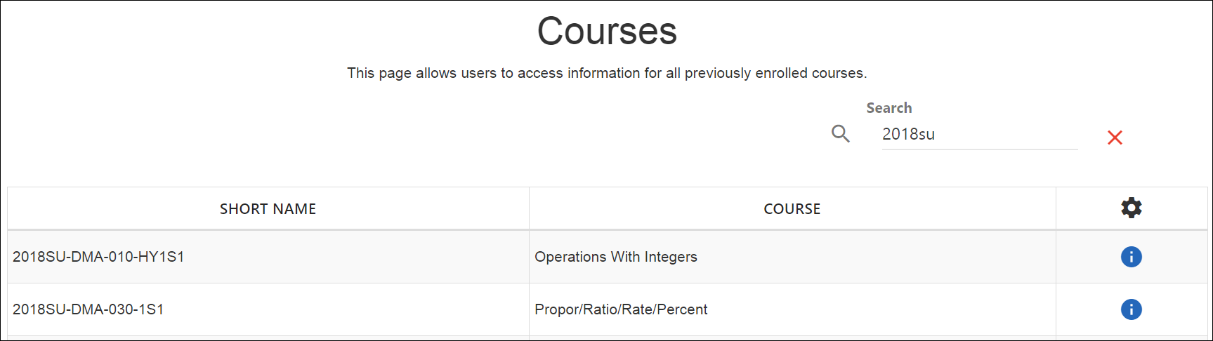

How to View Course Enrollments:
- At the Enrollments tab, select a course from the drop down list to see all students in that course.

Note that students click the “Get Tutoring” button to initiate a tutoring session, or submit a paper to the Paper Center for review.

Frequently Asked Questions:

- Can a student still receive tutoring if an instructor has not made a referral for them?

Yes, students will still be able to receive tutoring and paper review services without a referral.

- If an instructor requires a class of 20 students to submit essays to the NetTutor Paper Center, will they have to complete a referral for all 20 students?

There is now a “Bulk Refer” option to easily refer an entire class.

- How does a student know that they have been referred for tutoring?

When an instructor refers a student for tutoring or paper review, an email is automatically generated to notify the student that they have been referred to tutoring for a specific course.

- What is checked in the Paper Center during a paper review?

When a student submits an essay to the Paper Center, writing tutors check the students’ paper for grammatical errors, formatting issues, structure, and citations. Instructors can add specific instructions to tutors and students in a referral.

