Web Attendance Manual

Accessing Attendance Tracking

- Log in to WebAdvisor.

- Go to the Faculty Menu and click on Web Attendance Tracking.
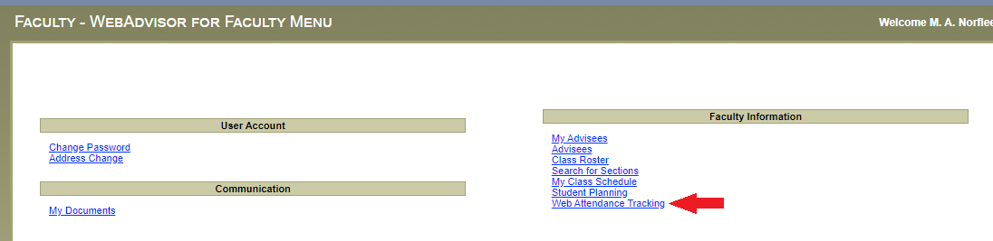
- In the Web Attendance Tracking Menu, click on the Attendance Tracking link.
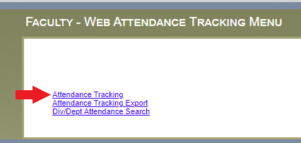
- Once you are in the Attendance Tracking page, you will be required to enter a Form Start Date. This date should be the date you are going to start attendance tracking.
NOTE: If the date entered is not within the section start and end dates or if the date is in the future, you will get an error message.

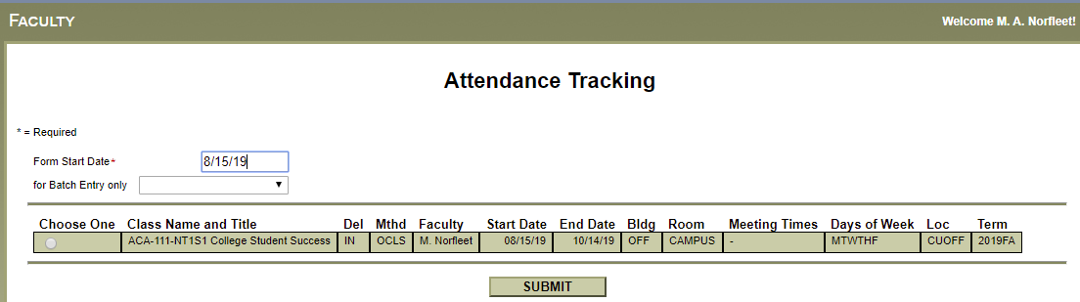

- Select a roster by clicking on a button in the Choose One field and clicking Submit.
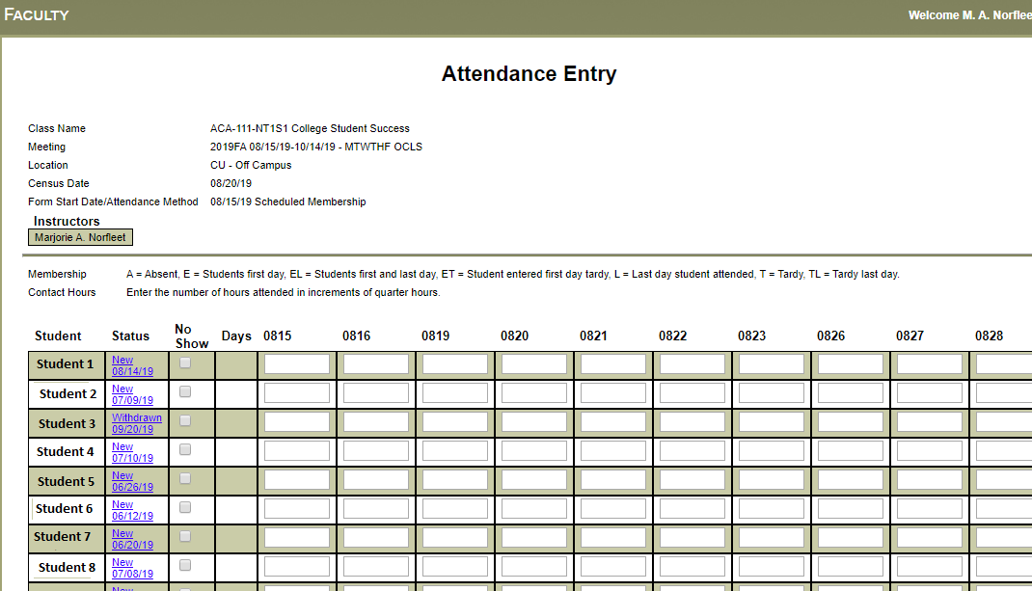
- If you wish to track attendance, this is where you will do that. See the Scheduled Membership Attendance Entry section for more information.

- If you do not wish to track attendance at this time, click Faculty Menu to return to the menu.

Scheduled Member Attendance Entry

- In the Attendance Tracking page in WebAdvisor, enter the Form Start Date (in this example, it will be the first day of the semester, 8/15/19), and select the section you are recording attendance for. Click Submit.
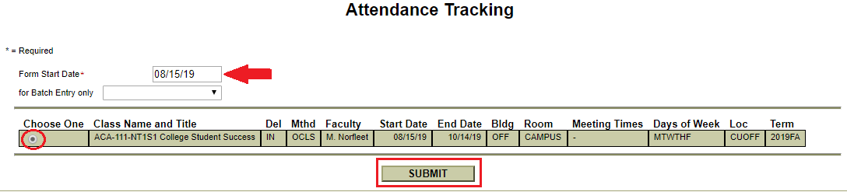

- You will now be in the Attendance Entry page which will show:
  - Student names,
  - Student status/status date (links to student profile),
  - No Show status,
  - Seat total (number of days in attendance),
  - Ten (10) scheduled meeting dates beginning on the Form Start Date that was entered on previous page, and
  - Last date of attendance.

- Enter the attendance type of ‘E’ (Entry – first day student entered class) to indicate the first date of attendance. Any blank dates after ‘E’ are considered present and are included in the attendance totals.
Note: Web Attendance does not allow you to enter any attendance codes prior to one of the ‘E’ codes. *See page 6 for types of Attendance Entries.
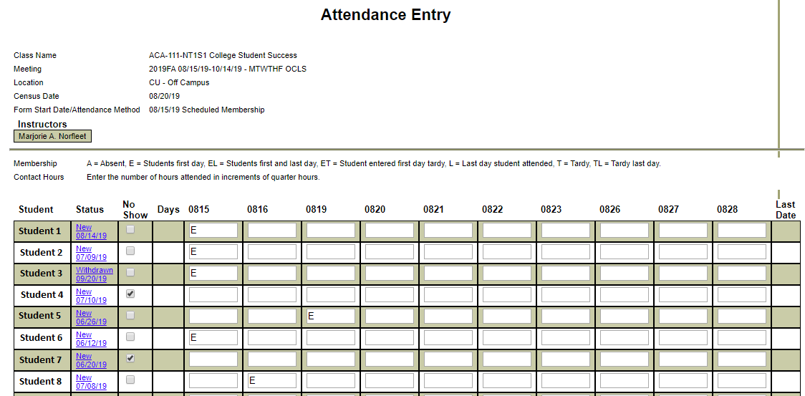
- Once all attendance is recorded, at the bottom of the Attendance Entry page, check the box next to “I hereby certify that I am submitting this attendance information via electronic transmission in lieu of a signature.” This is required if data was added or changed. Click Submit.

DO NOT check the final submission box until you have finalized all attendance for the semester. If you click the final submission box and submit, faculty may not make any changes to their web attendance roster.
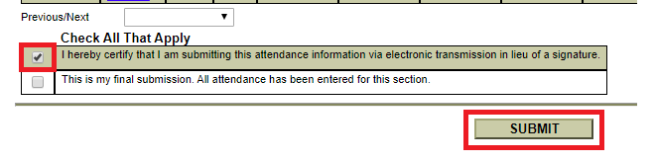

NOTE: If you are going to record attendance on another roster after submitting, you must re-enter the Form Start Date when you are back in the Attendance Tracking screen.

Acceptable Attendance Entries
FIRST DATE OF ATTENDANCE ONLY
E | First date of attendance. *Also see EL below.
No Show | Click the “No Show” box if the student NEVER attended the class. DO NOT check this box until after the Census Date (10% point).  WARNING: Checking this box removes the student from your roster and affects enrollment, financial aid, refunds, etc.
AFTER FIRST DATE OF ATTENDANCE RECORDED
A | Absent
L | Student’s last date of attendance (LDA). If you enter an ‘L,’ this will be the last time any attendance is recorded for that student.
EL | Student enters the class and never returned.  Note: NEVER replace ‘E’ with ‘L’ or FTE will not be counted. If first day of attendance and last day of attendance are the same date, replace ‘E’ with ‘EL’.

Other Types of Entries
No Shows | Select the “No Show” box if the student NEVER attended the class. DO NOT check this box until after the Census Date (10% point).  WARNING: Checking this box removes the student from your roster and affects enrollment, financial aid, refunds, etc.
Drops | Students who drop the course during the drop/add period will be removed from the Web Attendance roster. In addition, students who drop during this period are also removed from the Grading Roster for the course in WebAdvisor and no grade is entered.
Withdrawals | Codes of ‘EL’ (Entry date and last date attended) and ‘L’ (last date of attendance) are used to indicate a student’s last date of attendance in a course.  Instructors must enter an ‘L’ or ‘EL’ in the Attendance Entry screen for students being dropped before submitting a Drop Form (found on the Intranet). Any attendance codes previously entered after the entry of the ‘L’ on the withdrawn student will need to be removed by spacing out the codes. No ‘L’ code needs to be entered for no-shows. The last date of attendance recorded in WebAdvisor and on the Drop Form must match. When the Drop Form has been processed by the Registrar’s Office, the instructor will be notified.

Batch Attendance Tracking – Class Cancelled

- In the Attendance Tracking page in WebAdvisor, enter the date your class was cancelled in the Form Start Date (in this example, it will be 8/21/19).

- In the drop down box next to for Batch Entry only, select Class Cancelled.

- Select the class you are cancelling and click Submit.
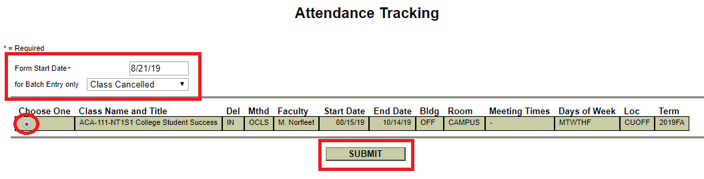
- In the Batch Attendance Entry page, you will be required to enter a comment explaining cancellation and assignment. The Make-up Form for missed or cancelled classes will continue to be used in addition to the batch attendance entry.

- The attendance type for the cancelled class date, 8/21/19, will default to ‘C’ (Cancelled).
Note: If a student has withdrawn from the class, you must delete the ‘C’ for that student. Otherwise, you will get an error message and will not be able to complete your batch entry.
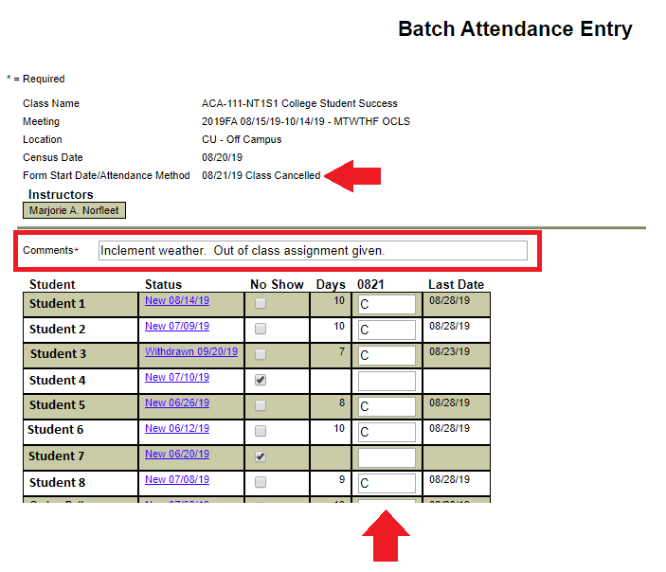
- Once this page is submitted, you will not be able to view the comments. If you would like to keep a copy for your records, print this screen.

- Once you have confirmed that all active students have a ‘C’ recorded for attendance, scroll to the bottom of the Batch Attendance Entry page, and check the box next to “I hereby certify that I am submitting this attendance information via electronic transmission in lieu of a signature.” This is required. Click Submit.

DO NOT check the final submission box until you have finalized all attendance for the semester. If you click the final submission box and submit, faculty may not make any changes to their web attendance roster.

Examples of Comments for Cancelled Classes
- Inclement weather. Online assignment given.
- Out-of-class activity assigned.
- Time added to subsequent class(es).

Batch Attendance Tracking – Make-up Days (Unscheduled Membership)

- In the Attendance Tracking page in WebAdvisor, enter the date your class is making up a missed day in the Form Start Date (in this example, it will be 8/24/19).

- In the drop down box next to for Batch Entry only, select Unscheduled Makeup.

- Select the class you are adding a make-up meeting date for and click Submit.
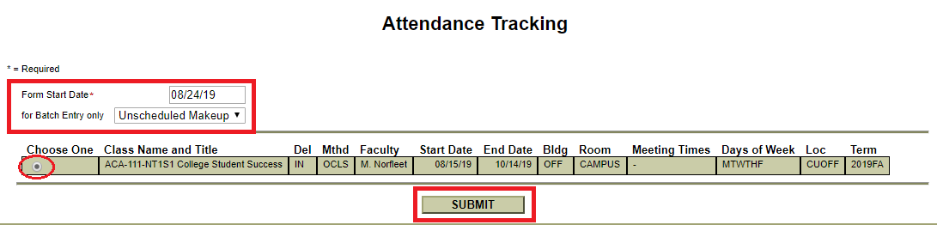
- In the Batch Attendance Entry page, you will be required to enter a comment explaining the reason or method for the make-up date.
- The attendance type for the make-up class date, 8/24/19, will default to ‘M’ (Makeup).
Note: If a student has withdrawn from the class, you must delete the ‘M’ for that student. Otherwise, you will get an error message and will not be able to complete your batch entry.
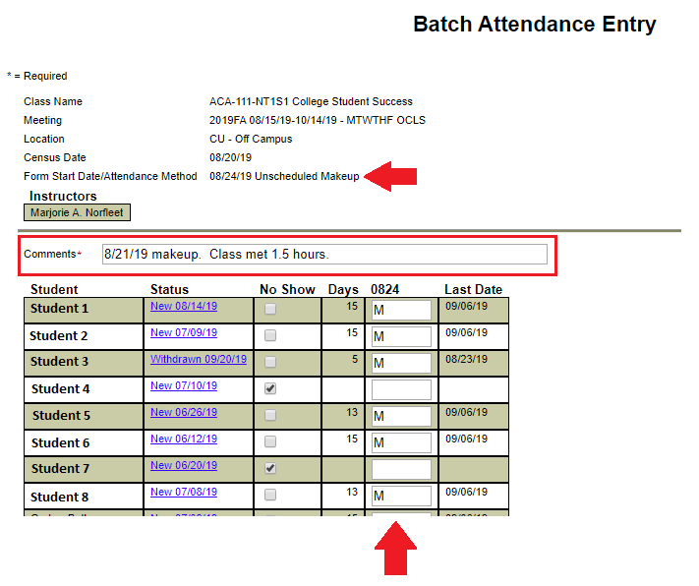
- Once this page is submitted, you will not be able to view the comments. If you would like to keep a copy for your records, print this screen.

- Once you have confirmed that all active students have a ‘M’ recorded for attendance, scroll to the bottom of the Batch Attendance Entry page, and check the box next to “I hereby certify that I am submitting this attendance information via electronic transmission in lieu of a signature.” This is required. Click Submit.

DO NOT check the final submission box until you have finalized all attendance for the semester. If you click the final submission box and submit, faculty may not make any changes to their web attendance roster.

Examples of Comments for Makeup Classes
- Date of cancelled class makeup. Class met for 1 hour.
- Inclement weather makeup. Met for 1.5 hours.

Additional Information

SUBMITTING 10% REPORTS FOR WEB ATTENDANCE
- Faculty must have all attendance entered in Web Advisor by the 10% Reports Due date.

- If your class has more than one roster in Web Advisor (see below for examples of this), you must record attendance on each roster weekly. The ‘E’ date for students must be entered on each roster as well.

- Follow the instructions that are sent out for ‘Moodle Census Reporting’ and rather than printing a hard copy, print to PDF and email to lw2356@wilsoncc.edu.

NOTES:
- Examples of sections that will have more than one roster in Web Advisor:
  - If a section has CLASS and LAB, there will be two rosters for that section in Web Advisor.
  - If a section has CLASS that, for example, meets in G100 on Monday and B100 on Wednesday, there will be two rosters for that section in Web Advisor.
  - If a section is hybrid or blended and has, for example, CLASS on campus in G100 and CLASS online, there will be two rosters for that section in Web Advisor.
  - If a section is hybrid or blended and has, for example, CLASS on campus in G100, CLASS online, and LAB on campus in G100, there will be three rosters for that section in Web Advisor.

- When using Web Attendance, you are not required to submit Never Attend or Late Entry Forms.

- Faculty must continue to use the Reinstate Form if a student is dropped and wants to be reinstated in the course.

- If a student is auditing a course:
  - An ‘E’ must still be recorded for the student.
  - The student’s final grade will be AU.
  - If the student is in a section with clinical but is not required to attend clinical, the student must be marked absent for each clinical meeting date.

