openNCCC

Overview
OpenNCCC is a collection of OER resources (open source textbooks, lessons, activities, and more) that can be used to supplement instruction by embedding it using the External Tool resource in Moodle.

Create an openNCCC Account
Go to https://opennccc.nccommunitycolleges.edu/ and click Sign In/Register to create an account. Use your official college email address (xx1234@wilsoncc.edu) to identify you as a Wilson CC user.
Search for resources by topic or by NCCCS course, save resources you find helpful to your My Items folder. These saved resources can be added to your Moodle courses using the External Tool resource.

Add an openNCCC External Tool Link to a Moodle Course
- In your Moodle course, click Create Learning Activity.
- Select External Tool.
- Enter an Activity Name of your choice.
- Select openNCCC as the Preconfigured Tool.
- Click Save and Display.
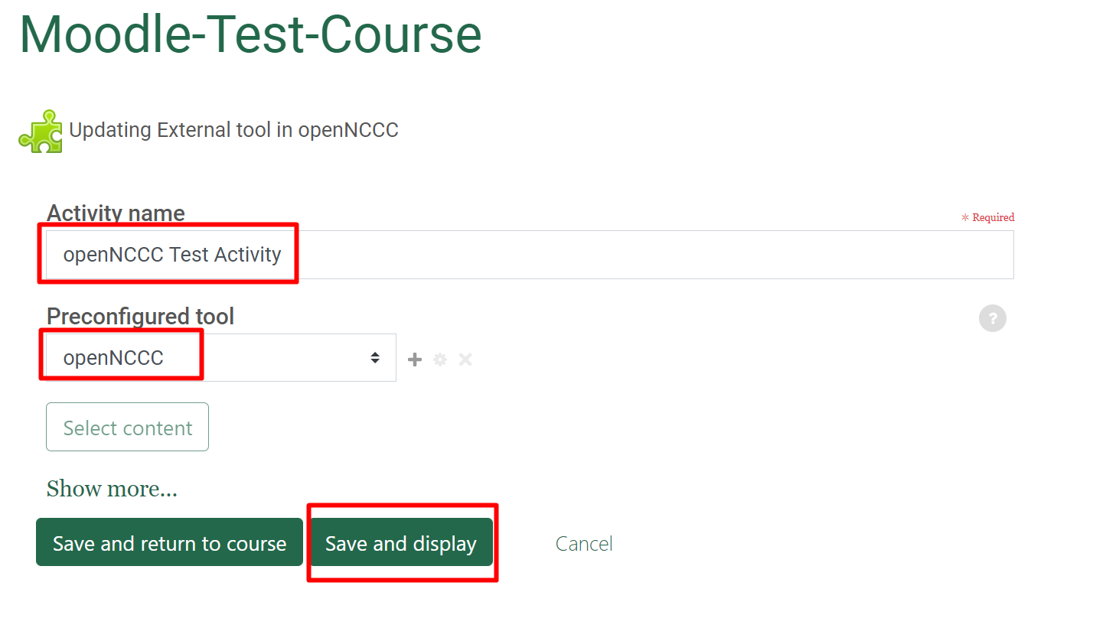
- This launches the openNCCC platform, where you will be able to view the openNCCC Collections available for your use.
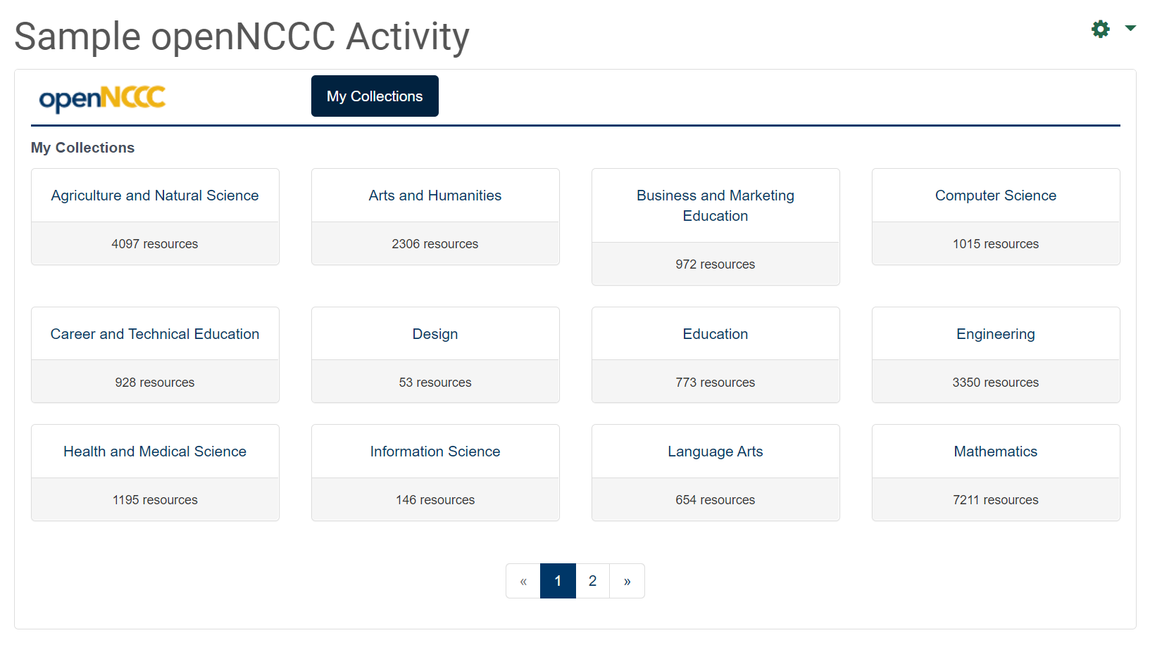
- Select a collection (category).
- Filter by course, subject, and/or material type.

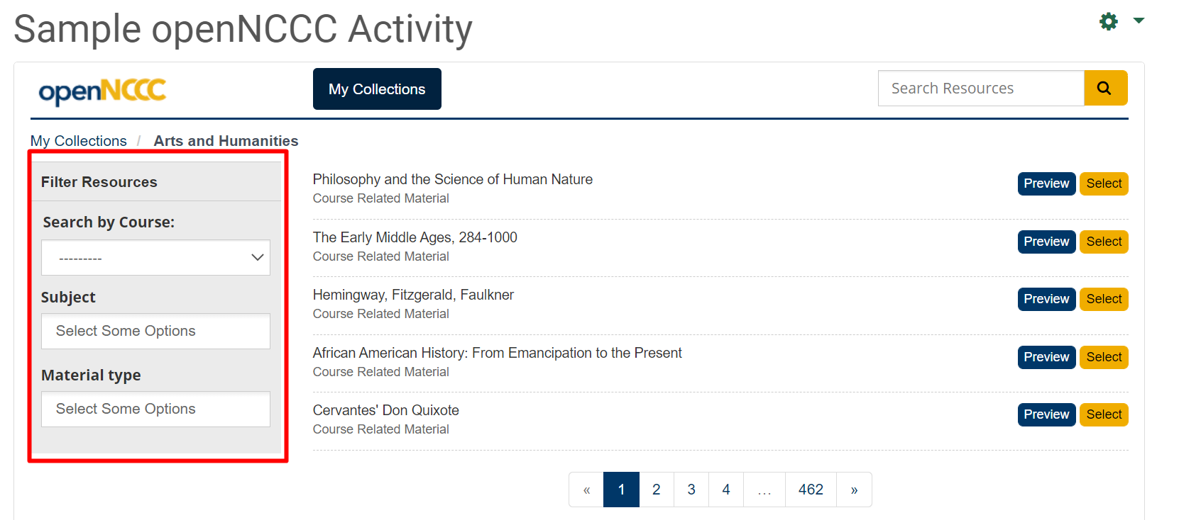

- As you select filters, the available resources will be narrowed down. If you do not see any results, remove or change one or more filters.
- In the example below, I selected the Arts and Humanities collection, I then selected the NCCCS Combined Course Library as the course, Art as the subject area, and ART 111 as the course from that subject. The available resources are listed on the right. Note that there may be multiple pages of listings.

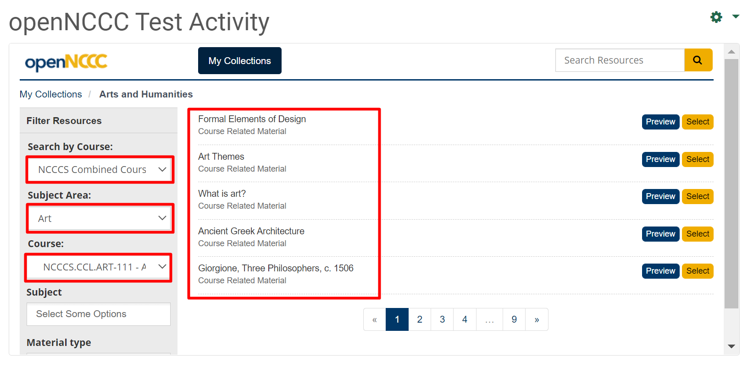

- Click Preview to view the content. Click Select to add the content to your course.

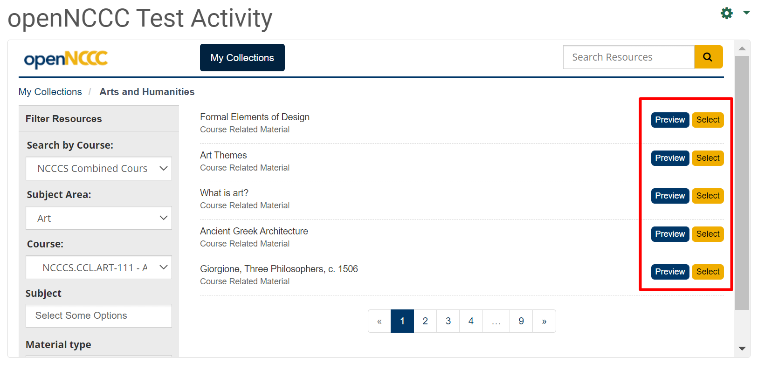

- In the example below, I chose a resource on Giorgione from Khan Academy.

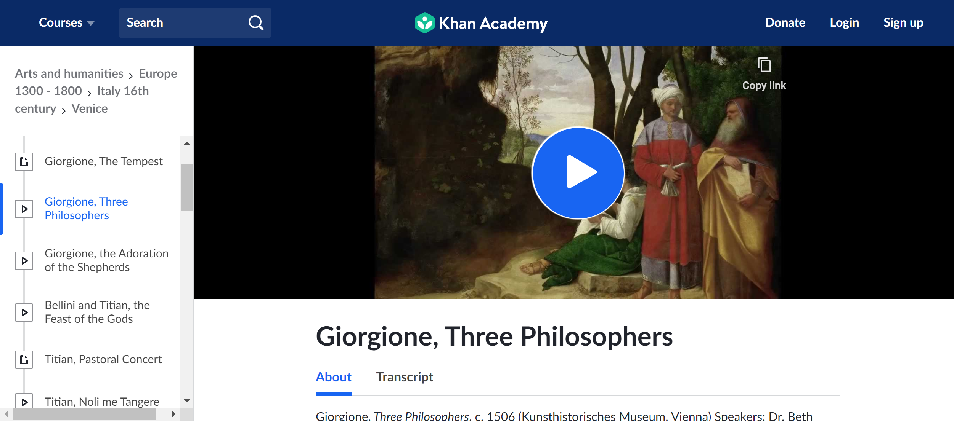

- Create a new external tool for each activity.

Save Activities to a My Items list for Future Reference
When previewing resources, if you find one you want to save for later, follow the instructions below to create and save resources to a My Items list.
- At the preview step (step 11), click the Save button and create a folder (name of your choice).

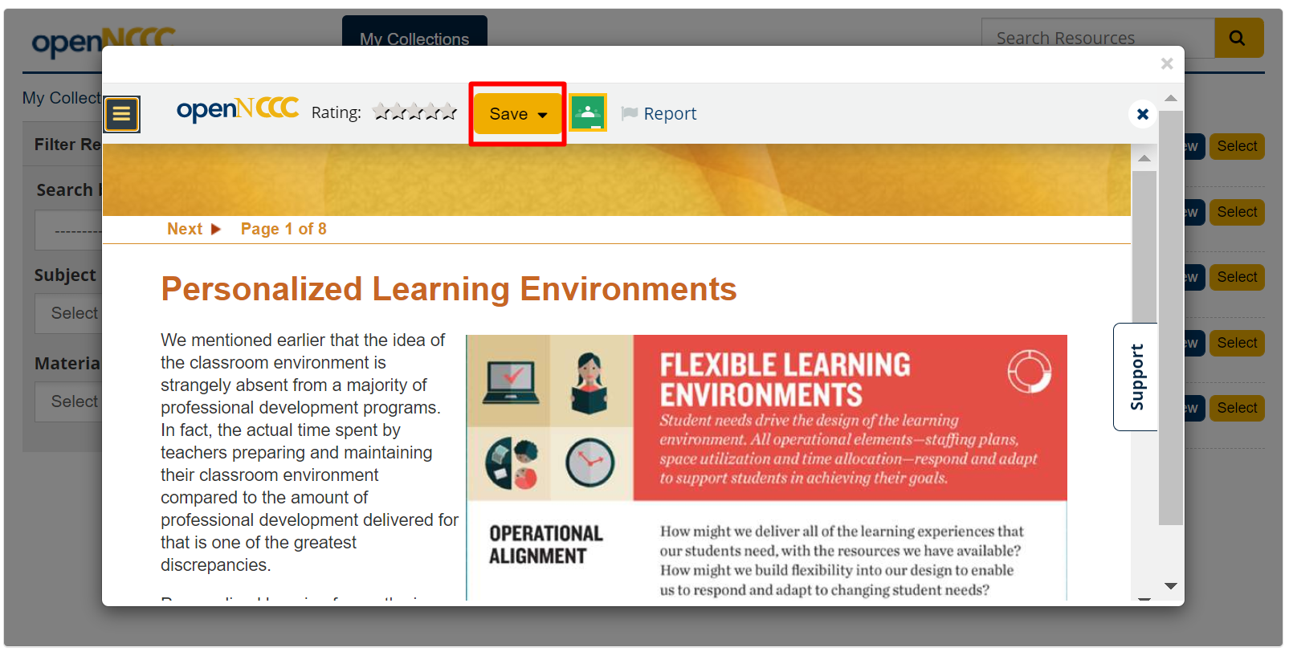

- After naming the folder, click Create and Save and that previewed item will be saved under My Items the next time you view Collections in openNCCC.

